

Vave™ Wireless Ultrasound

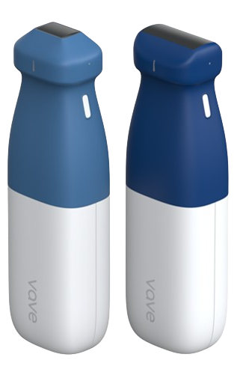
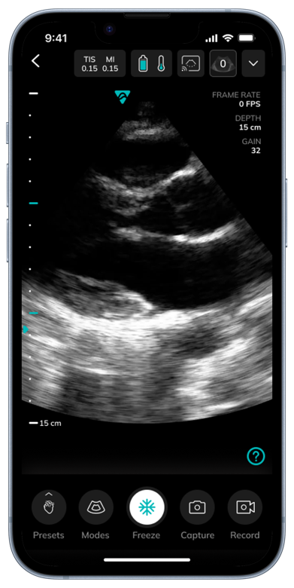
Table of Contents
About This Manual 5
Target Audience 5
Manufacturer 5

1 About the Vave Ultrasound System 5
System Description 6
Product Usage 6
Intended Use 6
Indications for Use 6
Contraindications 8
For Use in Surgical Environments 8
Additional Usage Notes: 8
Security and Incident Response 9
Recommended Cybersecurity Controls and Product Specification 9
Document Conventions 11
Screen Icons 12

2 Performing an Exam 13
Downloading the Vave Health App 13
iOS 13
Android 13
Interfaces & Communication Protocol 14
Updating the Vave Probe 14
Software Updates 14
Firmware Updates 14
The Vave Probe Battery 15
Charging the Battery 15
Inserting the Battery 15
Removing the Battery 15
Turning the Vave Probe and Vave App On/Off 16
Turning On the Vave Probe and Starting the Vave Health App 16
Exiting the Vave Health App and Turning Off the Vave Probe 16
Connecting the Vave Probe to the Smart Device 16
Exam Workflow Overview 17
Performing a Patient Exam 20
Imaging Display Overview 20
Selecting the Application Preset 20
Adjusting the image 23
Snap, Freeze/Unfreeze, Save Image and Cines 23
Measurements and Annotations 23
Vave Cast™ 25
Ending an Exam 25
Review Findings 25
Reviewing Images and Cines 26
Manage Images 26
Share Exams 27
Exam Discussion 28
Vave Assist™ (optional) 28
MedEd 29
Worklist Configuration 29
Modality Worklist 30
Import Modality Worklist 30
After Each Exam 31
After Each Use 31
Cleaning and Disinfecting the Vave Probe and Battery 31
Cleaning the Vave Probe and Battery 31
Cleaning the Charger 32
Disinfecting the Vave Probe and Battery 32
Intermediate-Level Disinfection 33
High-Level Disinfection 33
Cleaners and Disinfectants 33
Recharging the Battery 34
Storing the Vave Probe 34
Troubleshooting the Vave Probe 34
Additional Help 35

3 System Setup and Administrator’s Guide 36
Account Creating, Signing In and Out 36
Creating An Account 36
Register/Sign-In with Invitation Link 36
Signing In 36
Signing Out 36
Forgotten Password 36
Organizations 37
Managing Patient Information 37
Entering Patient Information 37
Settings 37
Profile Settings 37
Settings 38
Join Vave Cast™ 38
PACS Configuration 39
Imaging Settings 39
Vave Cloud™ 39
Vave Web Portal Guide for Administrators 40
Web Portal User Interface Layout and Usage 40
Administrative Tasks 41
Creating an Organization (Vave Administrator Task) 41
Managing an Organization 41
Adding a Member 41
Editing a Member’s Status 41
Creating a Probe (Vave Administrator Task) 41
Managing an Organization’s Probes 41
Creating a New User 41
Managing Users 41
Managing Exams (Discussion and Exam Details) 42
Managing Images and Cines 42
Managing Exam Folders 42
Sharing Exams 42
Copying Exams 43
Managing Your Profile 43
Resetting Your Password 43
Viewing Activity 43
Organizations 43
General Information Page 44
Members 45
PACS Configuration 45
Users 45
My Exams 46
My Portfolio 49
My Shared 51
Profile 52
Scanning Activity 52
About and Support 53
Worklist and PACS Configuration 54

4 Product Safety 54
Diagnostic Ultrasound Imaging 54
Ultrasound principles of operation 55
Ultrasound exams 55
Ultrasound biological interactions 55
Important Safety Warnings 55
Patient, Personnel, and Product Safety 55
Product Warnings 55
Biopsy Safety 57
Electrical Safety 58
Electromagnetic safety 59
Declaration of Electromagnetic Emissions 59
Electromagnetic Immunity 60
Electromagnetic Interference (EMI) 60
Recommended Separation Distance 60
Biological Safety 61
Allergic Reactions 61
Bioeffects 61
ALARA Principles 61
Output Display 62
Acoustic Power 63
Device Labels 64

5 Specifications and References 66
Compliance Statement 66
The Vave Wireless Ultrasound System 66
Product Classification 66
Product Model Number 66
System Specifications 66
Environmental operating, transient and storage conditions 66
System Dimensions 67
Accessories 68
iOS/Android Specifications 68
Battery Specifications 69
Battery Specifications: 69
Hardware 69
Standards 70
Biocompatibility 70
Electrical Safety 70
Federal 70
Labeling 70
Quality 70
Performance 70
Risk, Product Specification, Design Review, & Verification/Validation 70
Security & Privacy 71
Wireless 71
Wireless Compliance with FCC and ISEDC 71
ISEDC Radiation Exposure Statement 71
Acoustic Output Tables 72
B-Mode Operation – Phased Probe 72
Tissue Harmonic B-Mode Operation – Phased Probe 72
M-Mode Operation – Phased Probe 73
Color Doppler Mode Operation – Phased Probe 73
B-Mode Operation – Universal Probe 74
M-Mode Operation – Universal Probe 74
Color Doppler Mode Operation – Universal Probe 74
B-Mode Operation – Universal Probe – Vascular Preset 74
M-Mode Operation – Universal Probe – Vascular Preset 74
Color Doppler Mode Operation – Universal Probe – Vascular Preset 74
Acoustic Output Table Key 74
Control Effects Guidance Documents 76

Table of Figures
Figure 1.1: Vave Ultrasound System Clinical Applications and Modes of Operation 8
Figure 1.2: Vave Phased Probe Clinical Applications and Modes of Operation 8
Figure 1.3: Vave Universal Probe Clinical Applications and Modes of Operation 9
Figure 1.4: Network Security Diagram 11
Figure 1.5: Touch Gestures 12
Figure 1.6: Informational Icons Used in the Manual 12
Figure 1.7: Screen Icons 13
Figure 2.1: Charging the Battery 16
Figure 2.2: Inserting the Battery 16
Figure 2.3: Probe On/Off 17
Figure 3.1: Web Portal User Interface Layout 41
Figure 3.2: Organizations Page 44
Figure 3.3: General Information Page 45
Figure 3.4: Members Page 46
Figure 3.5: Users Page 47
Figure 3.6: My Exams Page, Expanded Image View Page 48
Figure 3.7: My Portfolio Page 50
Figure 3.8: Copying Exams to My Portfolio Example 51
Figure 3.9: My Shared Page 52
Figure 3.10: Profile Page 53
Figure 3.11: Scanning Activity Page 54
Figure 3.12: Worklist and PACS configuration 55
Figure 4.1: Electromagnetic Emissions Compliance 60
Figure 4.2: Immunity Test, Test Level, and Compliance Level 61
Figure 4.3: Recommended Separation Distances by Transmitter Frequency 61
Figure 4.4: Acoustic Measurement Precision and Uncertainty 64
Figure 4.5: Labels: Probe, Battery, Battery Charger and Probe Box 65
Figure 5.1: Product Model Number 67
Figure 5.2: Environmental Conditions 68
Figure 5.3: System Dimensions 68
Figure 5.4: Accessories 69
Figure 5.5: Battery Specifications 70
Figure 5.6: Hardware Warranty and Disposal 70
Figure 5.7: B-Mode Fundamental Acoustic Output Table Phased Probe 73
Figure 5.8: Tissue Harmonic B-Mode Acoustic Output Table Phased Probe 73
Figure 5.9: M-Mode Acoustic Output Table Phased Probe 74
Figure 5.10: Color Doppler Mode Acoustic Output Table Phased Probe 74
Figure 5.11: B-Mode Acoustic Output Table Universal Probe 75
Figure 5.12: B-Mode Vascular Preset Acoustic Output Table Universal Probe 75
Figure 5.13: M-Mode Acoustic Output Table Universal Probe 76
Figure 5.14: M-Mode Vascular Preset Acoustic Output Table Universal Probe 76
Figure 5.15: Color Doppler Mode Acoustic Output Table Universal Probe 77
Figure 5.16: Color Doppler Mode Vascular Preset Acoustic Output Table Universal Probe 77

About This Manual
Note:
- This document is meant to be used with VaveHealth 3.0 and above versions of the mobile application.
- VaveHealth 3.0 and above application is not backward compatible.

This user manual covers the use of the Vave Ultrasound System and meets FDA regulatory requirements. Install, operate, and maintain the Vave Ultrasound System according to the safety and operating procedures in this manual, and only for its intended purpose. Always use the information in this document with sound clinical judgment and best clinical procedures. Information in this Manual is subject to change. To obtain the latest version, go to www.vavehealth.com. You can also obtain a printed copy of this manual at no additional cost, go to www.vavehealth.com and contact Vave Health.
This document contains:
- Product Overview: Description, intended use, indications for use, contraindications, and manual conventions
- Performing an Exam: Performing a Patient's Exam
- System Setup and Administrator’s Guide: System set up and web interface
- Product Safety: Critical safety standards, principles, and policies
- References: Regulatory requirements, technical specifications, terms and conditions, glossary of terms, and acoustic output data

Target Audience
This document is written for trained healthcare professionals.

Manufacturer
Vave Health, Inc.
3031 Tisch Way #110
Plaza West, Suite
San Jose, CA 95128

About the Vave Ultrasound System
The Vave Wireless Ultrasound system is subject to local laws and regulations. Ensure that you follow applicable local laws and regulations when using the Vave Wireless Ultrasound system.
- Ensure you use the product as directed in this manual and according to its intended uses. Failure to do so could void the product's warranty and release Vave from any damage or injury resulting from this misuse.
- In compliance with part 15 of the FCC rules, operation of this device contains a general provision that devices may not cause interference and must accept any interference received.
- This ultrasound device may be used in all medical and domestic environments but may require special precautions regarding EMC. Follow the information provided in this manual regarding installation and use environments.
 Caution: | Do not operate the system in the presence of flammable gases or anesthetics.
- Image quality and diagnosis are the responsibility of the trained healthcare professionals performing exams.
- Keep product packaging with medical device. Do not dispose of the packaging.

System Description
The Vave Wireless Ultrasound is a wireless, pocket-sized diagnostic ultrasound device consisting of both hardware and a mobile application (“Vave Health App”). The purpose of the system is to provide a low-cost, easy to use and high-quality ultrasound platform for teaching and clinical applications.
The ultrasound probe (“Vave Probe”) uses a state-of-the-art piezoelectric transducer and houses a removeable lithium-ion battery and components required for ultrasound imaging and Wi-Fi connectivity. The Vave Wireless Ultrasound System includes Phased and Universal array probes to support a range of clinical indications.
The Vave Probe can wirelessly transmit data to a mobile application (“Vave Health App”), which displays the ultrasound images and allows certain image parameter modifications through its user interface. The mobile application runs on non-proprietary commercial display devices capable of supporting wireless connections (iOS or Android based tablets or phones -- purchased separately) so users can view images and control the Vave Probe on a mobile device. Ultrasound scans can be saved in an examination file on the device and exported for storage or printing.

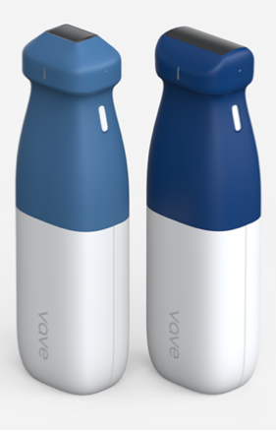
Vave Probe Vave Health App
(display device not included)
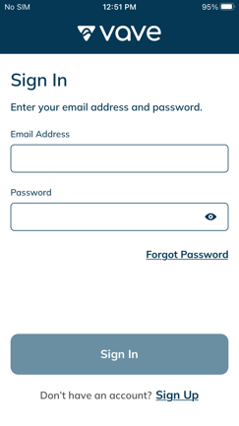

Product Usage
Indications for use and contraindications are noted below:

Intended Use
The Vave Probe is intended for diagnostic ultrasound imaging or fluid flow analysis of the human body.

Indications for Use
The Vave Wireless Ultrasound System is indicated for diagnostic ultrasound imaging in the following applications: Fetal/Obstetrics, Abdominal (includes Gynecology, Renal, and Urology), Pediatric, Musculoskeletal (Conventional), Musculoskeletal (Superficial), Small Organ (includes Breast, Thyroid, Scrotum), Thoracic/Pleural, Cardiac Adult, Cardiac Pediatric, Peripheral Vessel, and procedural guidance of needles into the body.
The Vave Wireless Ultrasound System is a transportable system that is intended for use in environments where healthcare is provided by trained healthcare professionals. (e.g., Hospital, clinic, medical office), home environment, road/air ambulance and other environments where healthcare is provided. The Vave Charger is to be used in a stationary setting.
Diagnostic Ultrasound Indications for Use
System: Vave Ultrasound System
Transducer: Vave Phased Probe, Vave Universal Probe
Intended Use: Diagnostic ultrasound imaging of the human body as in the chart below.

Figure 1.1: Vave Ultrasound System Clinical Applications and Modes of Operation
Clinical Application |  |  | Mode of Operation
General | Specific | B | M | Color Doppler | Combined (Specify)
Fetal Imaging & Other | Fetal/OB | X | X | X | B+M, B+C
Fetal Imaging & Other | Abdominal (gynecology, renal, and urology) | X | X | X | B+M, B+C
 | Pediatric | X | X | X | B+M, B+C
 | Small Organ (breast, thyroid, and scrotum) | X | X | X | B+M, B+C
 | Musculo-skeletal (Conventional) | X | X | X | B+M, B+C
 | Musculo-skeletal (Superficial) | X | X | X | B+M, B+C
 | Other (Thoracic/Pleural) | X | X | X | B+M, B+C
Cardiac | Cardiac Adult | X | X | X | B+M, B+C
Cardiac | Cardiac Pediatric | X | X | X | B+M, B+C
Peripheral Vascular | Peripheral Vessel (arteries, veins) | X | X | X | B+M, B+C
Peripheral Vascular | Other (Non-Vascular image guidance for needle/catheter placement) | X | X | X | B+M, B+C
X = Indication

Figure 1.2: Vave Phased Probe Clinical Applications and Modes of Operation
Clinical Application |  |  | Mode of Operation
General | Specific | B | M | Color Doppler | Combined (Specify)
Fetal Imaging & Other | Fetal/ OB | X | X | X | B+M, B+C
Fetal Imaging & Other | Abdominal (gynecology, renal, and urology) | X | X | X | B+M, B+C
 | Pediatric | X | X | X | B+M, B+C
 | Other (Thoracic/Pleural) | X | X | X | B+M, B+C
Cardiac | Cardiac Adult | X | X | X | B+M, B+C
Cardiac | Cardiac Pediatric | X | X | X | B+M, B+C
Peripheral  Vascular | Peripheral Vessel (arteries, veins) | X | X | X | B+M, B+C
Peripheral  Vascular | Other (Non-Vascular image guidance for needle/catheter placement) | X | X | X | B+M, B+C
X = Indication
Notes:
- Includes imaging to assist in:
- Needle and catheter placements in vascular or other anatomical structures, and
- Guidance for nerve block procedures.
Figure 1.3: Vave Universal Probe Clinical Applications and Modes of Operation
Clinical Application |  |  | Mode of Operation
General | Specific | B | M | Color Doppler | Combined (Specify)
Fetal Imaging & Other | Fetal/OB | X | X | X | B+M, B+C
Fetal Imaging & Other | Abdominal (gynecology, renal, and urology) | X | X | X | B+M, B+C
 | Pediatric | X | X | X | B+M, B+C
 | Small Organ (breast, thyroid, and scrotum) | X | X | X | B+M, B+C
 | Musculo-skeletal (Conventional) | X | X | X | B+M, B+C
 | Musculo-skeletal (Superficial) | X | X | X | B+M, B+C
 | Other (Thoracic/Pleural) | X | X | X | B+M, B+C
Cardiac | Cardiac Adult | X | X | X | B+M, B+C
Cardiac | Cardiac Pediatric | X | X | X | B+M, B+C
Peripheral Vascular | Peripheral Vessel (arteries, veins) | X | X | X | B+M, B+C
Peripheral Vascular | Other (Non-Vascular image guidance for needle/catheter placement) | X | X | X | B+M, B+C
X = Indication

Contraindications
The Vave Wireless Ultrasound is not intended for use in the following situations: Introducing the Vave Probe within a body cavity or organ (endocavitary use, e.g., rectum, vagina, or esophagus)

For Use in Surgical Environments
Prior to using the Vave Probe in a surgical intra-operative environment, perform a high-level disinfection (for instructions see High-Level Disinfection), then apply a single-use sterile sheath to the Vave Probe:
- Use only CIVCO REF 610-1212.
- Download and read the usage instructions from http://civco.com.

After using the Vave Probe, clean perform another high-level disinfection.
Caution: | If the sheath breaks during the intra-operative procedure, dispose the sheath and follow the same cleaning and high-level disinfection process as above, then cover the Vave Probe with a new sheath before continuing use.

Additional Usage Notes:
- Chemicals and gases in a surgical environment and altitudes below -382m or above 40000m in the patient’s environment may adversely impact the scanner and the exam.
- Always practice ALARA when scanning children and pregnant/nursing women, as they may be more susceptible to bioeffects from prolonged exposure to acoustic energy during scanner use.
- Extreme conditions in the patient environment may cause difficulty in scanning: humidity
(RH<15% and RH>90%) or extreme temperature (<0°C / 32°F or >40°C / 104°F).
- Users can be trained healthcare professionals, healthcare students, and in-home users under a physician’s care.
Caution: | Federal law restricts this device to sale by or on the order of a physician.

Security and Incident Response
It's crucial to follow these security practices to safeguard sensitive patient data, protect personal information, and ensure the reliable and secure operation of the Vave System
- Use secure passwords.
- Keep your operating system up to date with the latest recommended security patches.
- Use secure wireless equipment and protocols
- Lock your smart devices.
- Regularly update the Vave App.
- Vave will provide software update in case of any security vulnerabilities.

Please contact Vave support in case Vave mobile application can’t connect to Vave probe device. Vave support will evaluate the issue and advise you properly for your probe to become active.
Vave probes can detect fraudulent apps and Vave App can detect fraudulent probe and deny connectivity. App can present user a message in case of later.
Security is baked in the device and mobile application. Users do not need to do anything specific to secure the device. Users should follow the security instructions and best practices of their organization.

Recommended Cybersecurity Controls and Product Specification

1. Anti-Malware Software
- Recommendation: Install reputable anti-malware software or the one recommended by your IT team.
- Instructions: Ensure the software is always up-to-date and run regular scans to detect and remove any malware.
- Product Specifications: Compatible with the device’s operating system (e.g., iOS, Android). Ensure the anti-malware software supports real-time protection.

2. Use of a Firewall
- Recommendation: Please follow your IT groups security policy. If the IT team is unavailable, please enable and configure a firewall to monitor and control incoming and outgoing network traffic according to predefined security rules.
- Instructions:
  - For mobile devices: Use the built-in firewall settings, if available, or a reputable firewall app.
  - For computers: Utilize the built-in firewall features in Windows or macOS or consider third-party firewall solutions for enhanced protection.
- Product Specifications: Product is compatible with the device’s network configuration and operating system.

3. Password Requirements
- Recommendation: Please follow your IT team’s recommendation. Implement strong password policies for your mobile devices.
- Instructions:
  - Use complex passwords that include a combination of letters (upper and lower case), numbers, and special characters to access your mobile device. Optionally enable biometrics.
  - Avoid using easily guessable information such as birthdays or common words.
  - Change passwords regularly and do not reuse passwords across different accounts.
  - Enable multi-factor authentication (MFA) where possible.
- Product Specifications: Vave password management service provides a second level of protection.

4. Software Updates
- Recommendation: Regularly update the device’s operating system and all installed applications.
- Instructions: Enable automatic updates to ensure the latest security patches are applied promptly.
- Product Specifications: Ensure the device has sufficient storage and processing capability to handle updates efficiently.

5. Encryption
- Recommendation: Use encryption to protect sensitive data.
- Instructions:
  - For mobile devices: Enable device encryption through the settings menu.
  - For computers: Use built-in encryption tools such as BitLocker (Windows) or FileVault (macOS).
- Product Specifications: Ensure the device supports the required encryption standards and has the necessary hardware capabilities. Vave application stores images in secure encrypted folder on the device

6. Network Security
- Recommendation: Secure the network environment.
- Instructions:
  - Use WPA3 or at least WPA2 encryption for Wi-Fi networks.
  - Change default router passwords and update firmware regularly.
- Product Specifications: Ensure the networking equipment is compatible with modern encryption standards and supports firmware updates.

7. User Access Controls
- Recommendation: Implement strict user access controls.
- Instructions:
  - Limit administrative privileges to necessary personnel only.
  - Use role-based access control (RBAC) to restrict access to sensitive information.
- Product Specifications: The system should support RBAC and other access control mechanisms.

Here is a network security diagram that captures the recommended cybersecurity controls:
Figure 1.4: Network Security Diagram
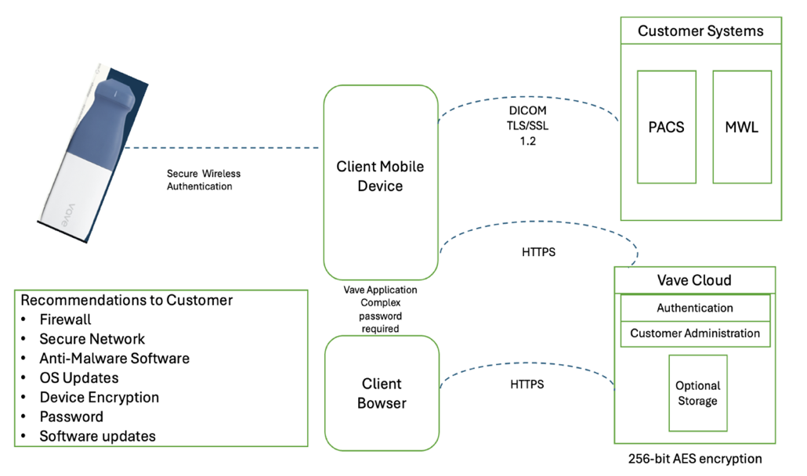
- Mobile and web application connect to backend services using https protocol on port: 443/8443.
- All ports are both incoming and outgoing.
- Mobile application sends information to customer’s PACS server over TLS/SSL (Transport Layer Security 1.2/Secure Socket Layer). Data is encrypted data during transmission to ensure privacy and data integrity.
- PACS servers are deployed at customer site. Customer configures our application with proper information to connect with their PACS server. Customer is responsible for configuring their PACS server to protect it from Cybersecurity attack. Vave application sends patient information (name, MRN number, etc.), images and cine to Customer’s PACS server. Port number is configured by customer.
- As depicted in the network security diagram, the approved destination endpoints are:
  - Vave Mobile application on Client Mobile device
  - Client Browser
  - Vave Cloud and
  - Customer system: PACS server
- Customers should make sure that they are using secure ports and follow their IT policies.

Decommissioning Mobile devices:
If you intend to decommission your mobile device:
  - iOS: Remove the Vave Mobile App to remove any sensitive information from the mobile device.
  - Android: Uninstall Vave Mobile App to delete any sensitive information from the mobile device.
Note: A machine-readable version (JSON) of the Software Bill of Materials (SBOM) can be obtained by contacting our support team via email at support@vavehealth.com

Document Conventions
Figure 1.5: Touch Gestures
 | Drag  Press and move in any direction |  | Swipe  Press and quickly move finger left or right
 | Tap  Press and release press quickly |  | Pinch  Press with two fingers and bring them together
 | Press and Hold  Press and hold press |  | Zoom  Press with two fingers and spread them out

Figure 1.6: Informational Icons Used in the Manual
Level of Risk | Danger, Warning, Caution: Possible risks beyond the reasonable control of Vave Health.
Note | Information/Suggestions

Screen Icons
Figure 1.7: Screen Icons
 | Abdominal |  |  | Battery Full |  |  | Scanning Button |  |  | Home
 | Cardiac |  |  | Battery 60% |  |  | Mode Select |  |  | Edit (applied in Renaming Exam)
 | Lung |  |  | Battery 30% |  |  | Record Cine |  |  | Patient Data
 | OB/GYN |  |  | Battery Empty |  |  | Capture Image |  |  | Share
 | Vascular |  |  | Export Destination |  |  | Save Single Frame |  |  | Menu
 | Exam Folder |  |  | Shared Indicator |  |  | Save Frames Range |  |  | Image Settings
 | Sync |  |  | Cine Indicator |  |  | Vave Assist |  |  | Scanning Activity
 | Sync Not Started Yet |  |  | Number of Cines in Exam Package |  |  | Join Session |  |  | Support
 | Sync in Progress |  |  | Number of Files in Exam Package |  |  | Probe Settings |  |  | About
 | Sync Done |  |  | Password Shown |  |  | Probe Element Check |  |  | Send System Logs
 | File not Physically on the Device (but on the Cloud) |  |  | Password Hidden |  |  | Probe Temperature |  |  | More Icon
 | Downloading from Cloud in Progress |  |  | Vave Cast

Performing an Exam
This chapter explains how to install and use your Vave Probe safely and effectively.
Note | Refer to the safety section of this manual before handling the Vave Probe.
Caution: | Ensure your mobile device requires a passcode, PIN, pattern, or biometric identification for access. We recommend configuring the device to lock after a maximum of 15 minutes of inactivity.  Ensure your mobile device follows your institution’s security policy.

Downloading the Vave Health App
The Vave Health App can be downloaded onto an iOS or Android device.

iOS
Operating system required: iOS 15+
To download the Vave Health App:
- Go to the App store and search for the “Vave Wireless Ultrasound”
- To download, tap the Install button and follow the on-screen instructions
- To launch, tap the Open button
- If you can’t find the App, your device might not meet the minimum requirement, or the App might not be available in your country

Android
Operating system required: Android™ 11+
Before downloading the Vave Health App, you need to have a Google Play Store account. If you can’t find the App, your device might not meet the minimum requirement, or the App might not be available in your country.
- Go to the app store and search for the “Vave Wireless Ultrasound”
- To download, tap the Install button and follow the on-screen instructions
- To launch, tap the Open button

Interfaces & Communication Protocol
The Vave mobile application uses the following interfaces and communication protocols:
- Interfaces
  - Wi-Fi 2.4 GHz, Wi-Fi 5 GHz
  - BLE
  - Cellular
- Communication protocols
  - TCP
  - UDP
  - HTTPS – to connect to internet
- User should make sure that Wi-Fi and Bluetooth are turned on for Vave mobile application and device to connect and operate device properly.
- Vave mobile application is designed to connect to probes WIFI even when the probe is not connected to Internet after initial user registration. User needs connectivity to internet every 30 days.
- Minimum Networking Requirements
  - Vave ultrasound device connects to Vave-mobile application using our built in WIFI router.
- Supported Encryption Interfaces
  - HTTPS and TLS 1.2 are used for data transfer.
  - Data at rest is AES 256 encrypted.
- Responding to Cybersecurity Vulnerabilities or Incidents
  - Customer’s IT team should implement continuous monitoring tools to detect unusual or unauthorized activity.
  - Customer should contact Vave at support@vavehealth.com to report any suspicious activity.

Updating the Vave Probe
Ensure that the Vave Probe is kept up to date with the latest software and firmware levels.

Software Updates
Update notifications will appear in the Vave Health App, as well as in the App store or Google Play Store when they become available. If the update is mandatory, you will not be able to use the Vave Health App until you have downloaded the update.

Firmware Updates
The Firmware update will automatically start when there is a new Firmware version available in the Vave mobile application. The Firmware update may stop if the battery is not charged above 50%. The Firmware update will go through the following 5 step process:
Step 1: App will connect to probe and start the update process
Step 2: Probe LED light will begin blinking white
Step 3: Probe LED light will turn sold white
Step 4: Probe LED light will turn solid blue
Step 5: Probe LED light will turn solid green
If the update is successful, the application will prompt the user to connect to the probe’s WIFI and show the firmware update complete screen. The User can click on “Start exam” button to start exam. If the screen stating that the upgrade was not successful appears, a prompt to try again will appear that the user should follow.
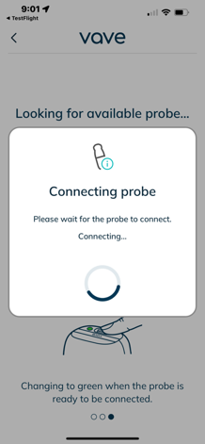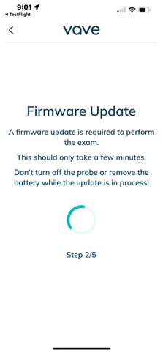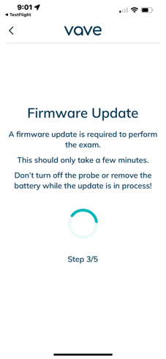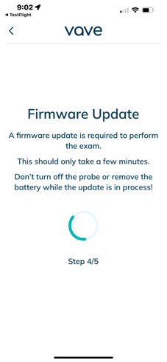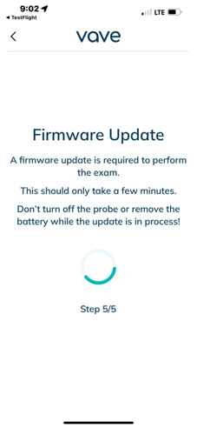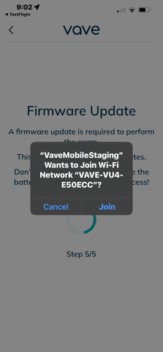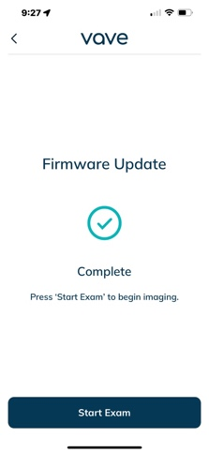

The Vave support team will address all customer concerns, including any cybersecurity concerns. Vave will push all software updates by releasing a new version of the software and using App Store and Playstore distribution mechanism to make it available to customers.

The Vave Probe Battery
When you receive your Vave Probe, charge the battery to 100% before use.

Charging the Battery
- Connect the line cord of the AC power adapter to an indoor electrical outlet
- Connect the AC power adapter to the receptacle on the battery charger
- Note that the charger LED toggles between yellow and green when power is applied
- Remove the battery from the Vave Probe by following the instructions on Removing the Battery, below
- Insert the battery into a slot on the battery charger
- The LED will stay yellow when the battery is charging
- The LED will stay green when the battery is fully charged

Figure 2.1: Charging the Battery
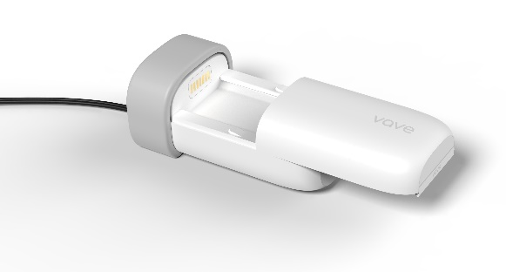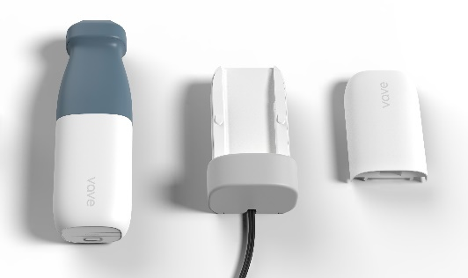

Inserting the Battery
To insert the battery into the Vave Probe:
- Make sure that the battery contacts are facing downward and that the battery label is facing the Vave Probe.
- Slide the battery into the Vave Probe until it locks into place.
Note that Vave batteries are interchangeable with all other Vave probes.

Figure 2.2: Inserting the Battery
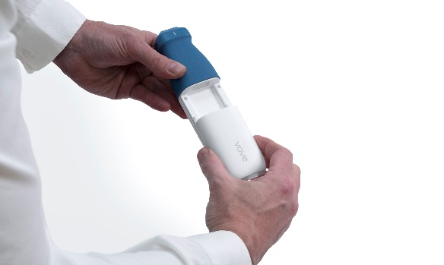

Removing the Battery
To remove the battery from the Vave Probe:
- Pull the battery away from the nosepiece of the Vave Probe
- Slide it all the way off

Turning the Vave Probe and Vave App On/Off
Make sure you have the Vave Probe, and also your smart device with the Vave Health App installed.

Turning On the Vave Probe and Starting the Vave Health App
- To turn on the Vave Probe, press the power button on the probe for 1 second. The blue light on the probe base will turn on, changing to green when the probe is ready to be connected
- Next, open the Vave Health App on your smart device’s home screen to begin scanning.

Figure 2.3: Probe On/Off
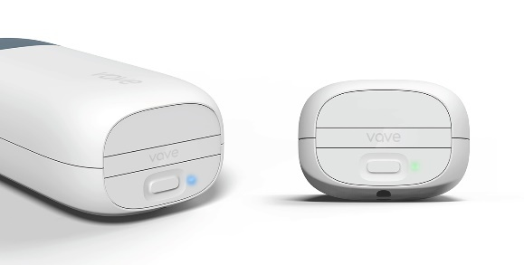

Exiting the Vave Health App and Turning Off the Vave Probe
- To close the App, exit the Vave Health App — any open exam will be saved, even if you close the app without ending the current exam session
- To turn off the probe, press the power button on the probe, and the light will turn off

Connecting the Vave Probe to the Smart Device
- Please read Interface and Communication section of this manual before proceeding.
- Open the Vave Health App and turn on your probe.
- Tap the circular Scan button in the center of the bottom menu on the Home screen and wait for the light to turn from blue to green.
- The App guides you through the connection process where you will join the probe Wi-Fi and when connected, the Imaging screen appears, and you can start an ultrasound scan.

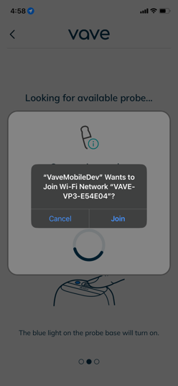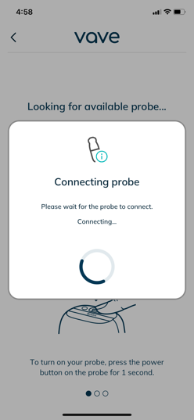

Note | Alternatively, you can manually connect your Probe before entering the App by going to your Wi-Fi settings and selecting the Wi-Fi network beginning with “VAVE-VP3”.

Exam Workflow Overview
 | Caution: |  | Before use, carefully inspect the probe. Always inspect the probe before and after cleaning, disinfection, or use.
Sign-In Page |  | When you open the Vave Health App, it displays a sign-in screen for your user ID/Email and password. After tapping Continue, you can enter your password and tap Sign In to submit the password and log in. |  | 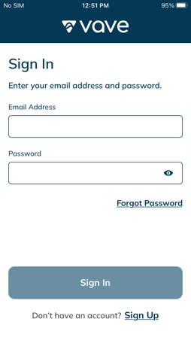
Menu Options |  |  |  | Scanning Tools 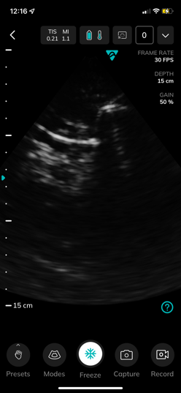 | 1 2 3 4 5 6    1 Acoustic Power, TIS/MI  2 and 3 Battery and Temperature  4 VaveCast QR Code  5 Image Gallery  6 Patient Info  7 8 9 10 11    7 Application Preset  8 Image Mode  9 Freeze  10 and 11 Single and Multiple image capture (cine)

How to Begin Scanning | - Once you’re signed in, you will see the Home screen. Turn on the probe. Tap the circular Scan Start Exam in the center of the bottom menu to start scanning.  - The app guides you through the connection process.  - Once you’re connected to the probe, you can start the ultrasound scan. | 1 2 3  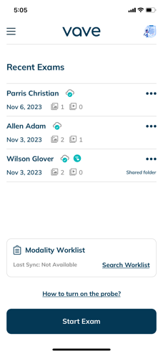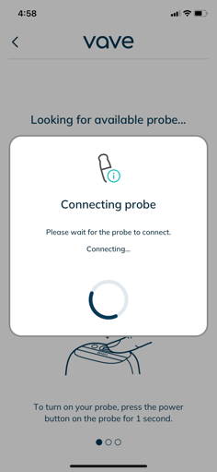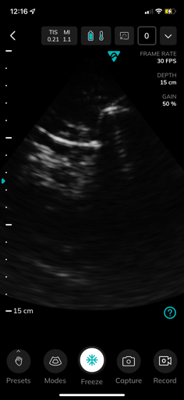
Select Application Preset | Depending on the clinical indication, choose the desired preset | 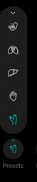 | - OB/GYN  - Lung  - Abdominal  - Cardiac  - Vascular

Enter Patient Information | Tab more icon and click Patient information | 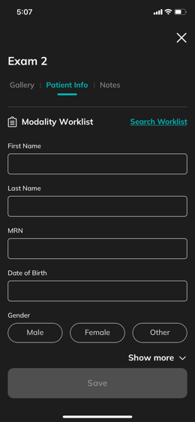
Imaging Screen | Here you can:  - Manipulate the depth, gain, and focus position of the image.  - Freeze or save images/movie clips. | 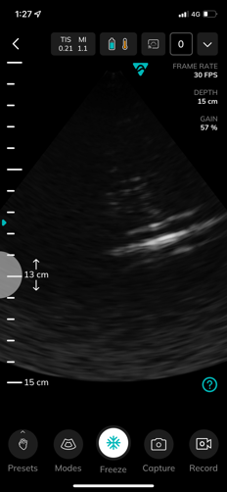  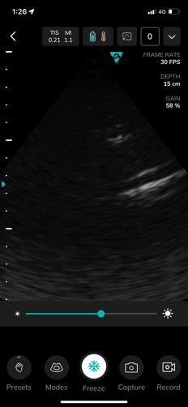  1 2

Gallery | During imaging sessions, you can:  - Evaluate and edit images and cines acquired during the exam.  - Access Patient Data, Exam Notes and Discussions. | 1 2  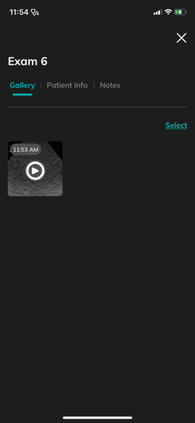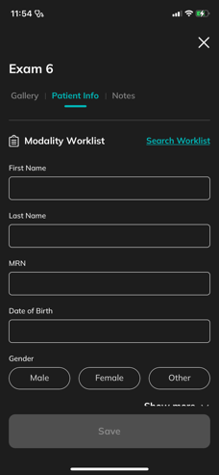

Exams Screen | Tap the Exams option in the menu of your Home screen to review all of your Exams and access My Portfolio and My Shared tab, ref Review Findings on p23. | 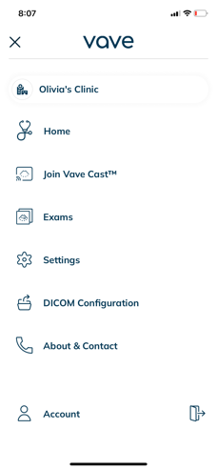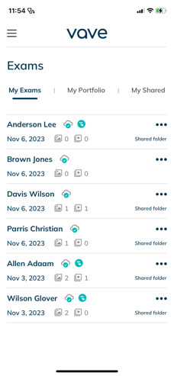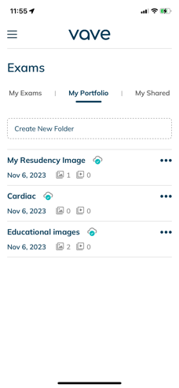

Performing a Patient Exam
Typical use of the Vave Probe is 5 minutes of continuous scanning, followed by 10 minutes in standby mode or powered off. Longer scanning sessions (>15min) are possible but may incur a thermal buildup noticeable to the user. In the event this occurs the system may undergo an automatic thermal shutdown to prevent excessive heat accumulation or any potential harm

Imaging Display Overview
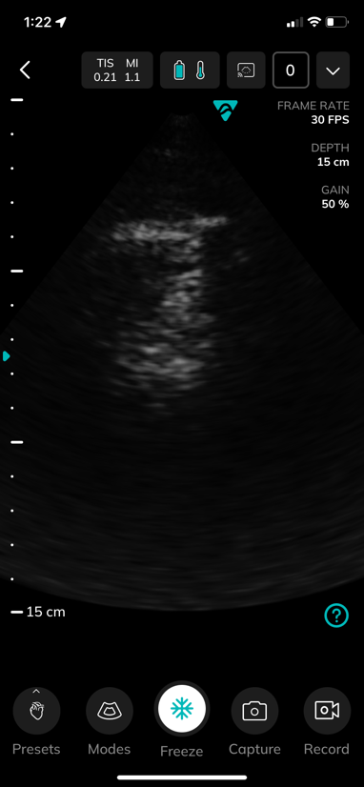 | The imaging display  screen includes:  - Exam Information  (TIS Value: 0.4 and MI Value: 1.0)  - Image Information  (Preset, Frame Rate, etc.)  - An ultrasound image in  the center of the screen | Modes, Capture tools Gallery Icons:  Mode Select (Fast/Slow Flow,  M-Mode, return to 2D)  Image/Video Capture   Freeze Button  Record CINE   Image Gallery

Selecting the Application Preset
Tapping the Modes icon in the bottom left corner opens a Mode bar with a choice of three modes: Fast Flow, Slow Flow, and M-Mode. To exit a mode, tap the red “End” button at the bottom of the screen.
Some of the modes may not appear on each probe.
B-Mode | When you start an exam, the Vave Probe defaults to B-Mode — or brightness mode, sometimes referred to as "2D Mode" with two-dimensional imaging displayed in grayscale. | 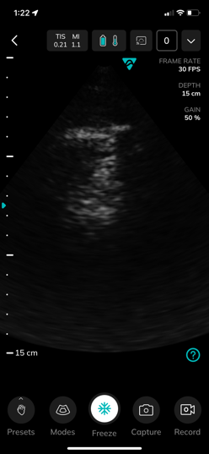

Color Doppler Mode (if available on probe) | - Tap the Mode control.  - To access Color Doppler Mode, tap either Fast Flow or Slow Flow in the Mode bar.  - Adjust your region of interest — indicated by a white line — by pinching your app screen to adjust the width and lateral position, and the proximal and distal bounds of the box. | 1 2 3  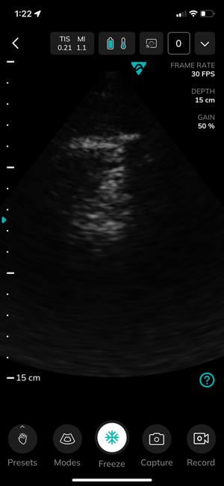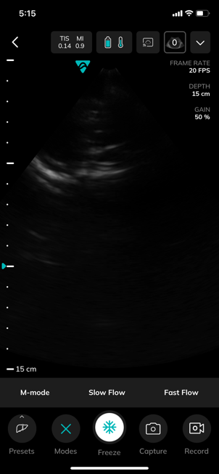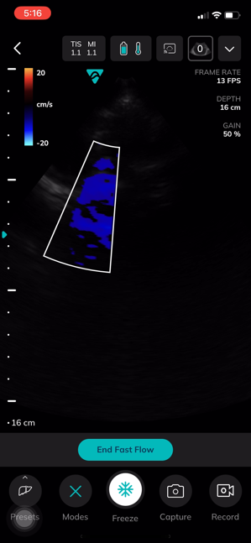  Note  You can also drag and drop the region of interest to a different location.

Color Doppler Mode – Vascular (if available on probe) | - Tap the Mode control.  - To access Color Doppler Mode, tap either Fast Flow or Slow Flow in the Mode bar.  - Adjust your region of interest — indicated by a white line — by pinching your app screen to adjust the width and lateral position, and the proximal and distal bounds of the box. | 1 2 3  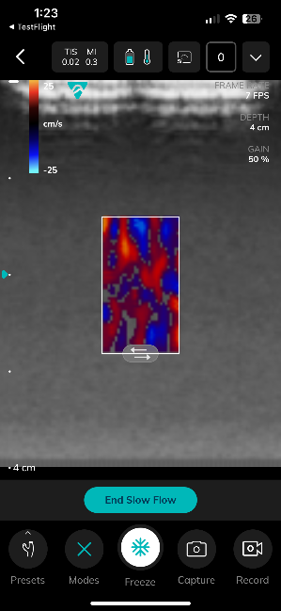  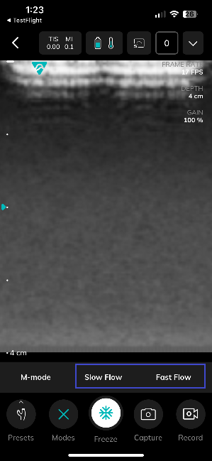  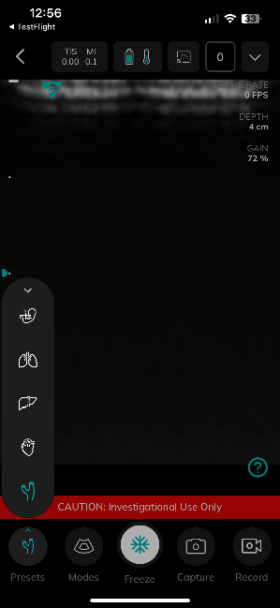  Note  You can also drag and drop the region of interest to a different location.
Vascular ROI Shape – Moving and Steering | - Tap the Mode control.  - To access Color Doppler Mode, tap either Fast Flow or Slow Flow in the Mode bar.  - Adjust your region of interest — Press the right or left steering arrow to steer either to right or left indicated by a white line — by moving the ROI close to edge of the imaging area. | 1 2 3  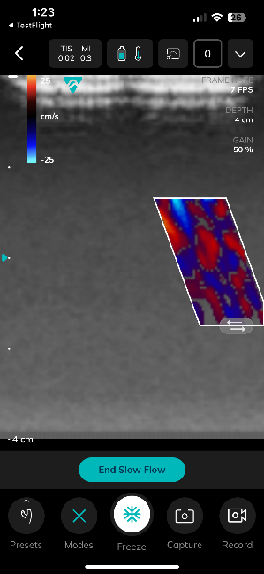  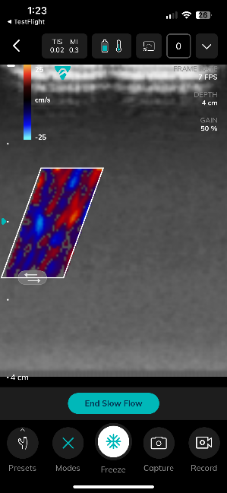  Note  You can also drag and drop the region of interest to a different location.

M-Mode (if available on probe) | - Choose M-Mode in the Mode bar.  - Initiate M-Mode by positioning your M-Mode cursor.  - When you release the M-Mode cursor, the M-Mode strip appears just below the B-Mode reference image. | 1 2 3  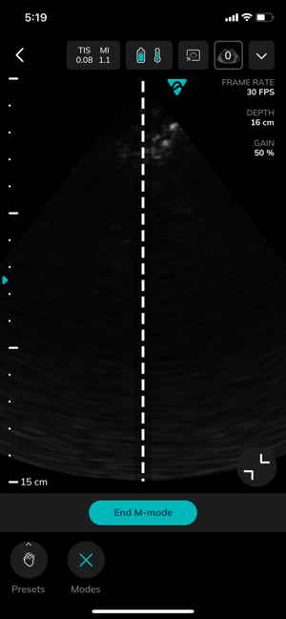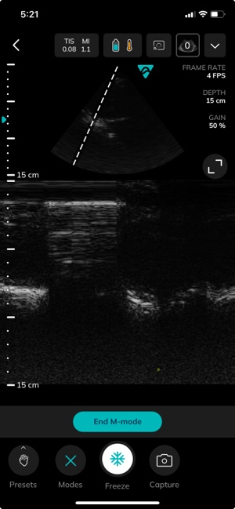  Note  You can further adjust the M-Mode cursor on the B-mode reference image while the M-Mode strip is displayed.  After pressing the freeze button, you can scroll back and forth through the M-Mode strip.

Adjusting the image
- To adjust Depth, swipe up (shallower) or down (deeper) over the ruler on the left side of the screen
- To manually adjust Gain, swipe left-to-right (increase) or right-to-left (decrease) on the ultrasound image
- You can adjust the Focal Point to a depth of 8 cm or less with a long press on the desired location
in the ruler area. The teal triangle to the left of the ruler indicates the current focal depth.
- Zoom In/Zoom Out Captured Images (not while scanning):
  - Use the pinch/zoom gesture  to zoom in/out of an area on the image.
  - After zooming in, you can adjust the magnified area of the image by sliding your finger. This action shifts the viewed section of the image rather than moving the entire image itself.

Snap, Freeze/Unfreeze, Save Image and Cines
- To save an image directly to the gallery, tap the camera icon. The number displayed will increment with each capture.
- To freeze/unfreeze a live image, tap the snowflake icon and then adjust the frame by horizontally sliding the frame slider.
- To save a frozen image, tap the save image icon to the left of the freeze button. To save the frozen cine, press the save cine icon to the right of the freeze button.
- To record a cine, tap the record icon during live imaging; to stop the recording, tap the record icon again, and your recording will be automatically saved to the Exam.

Measurements and Annotations
From scanning screen, after freezing the image, you can access the following tools: Linear Measurements, Area Measurements and Text Annotations:
Performing Measurements and Annotations | - Press Freeze.  - To measure, select Measurement Tool (Linear or Area Tool). -–or-- Tap the “T” Type icon to activate annotations. | 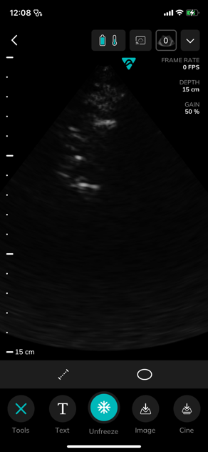  2 1
Linear Measure | Note  To move a linear measurement, drag and drop each end of the line individually. The displayed value will automatically update with each endpoint position change. |  | 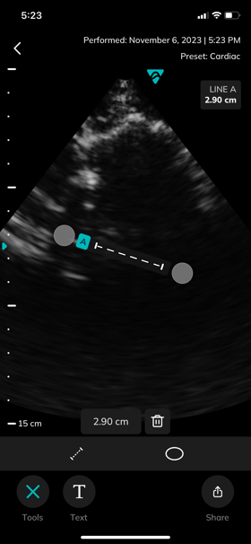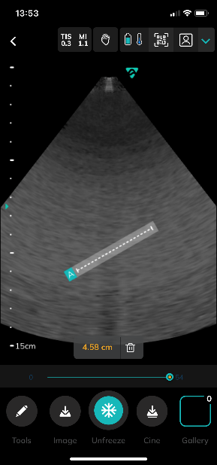
Area Measure | Note  To adjust an area measurement, drag and drop the whole area measurement  --or--  adjust size and shape by dragging and dropping individual points of the default area outline. The displayed value will update with each waypoint position change. |  | 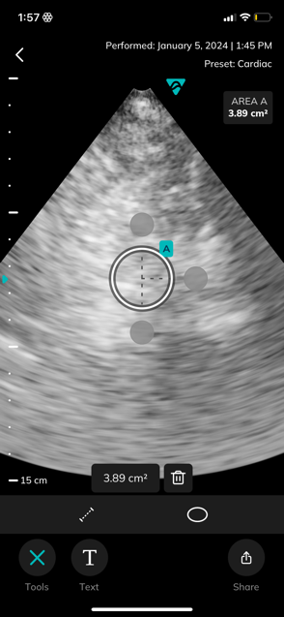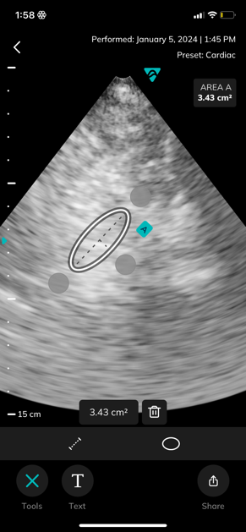
Text Annotations | - A text box and keyboard appear. Start typing notes.  - When finished, tap the image. The text box and keyboard disappears and the text turns green, indicating that the text can be dragged to the desired location.  - When positioned, tap the image to complete the annotation, and the text will turn to white.  Note  Drag the text to any point on the screen, or delete it, by tapping the trash can at the bottom. Text and Measurements can be captured and saved to the image gallery. |  |  | 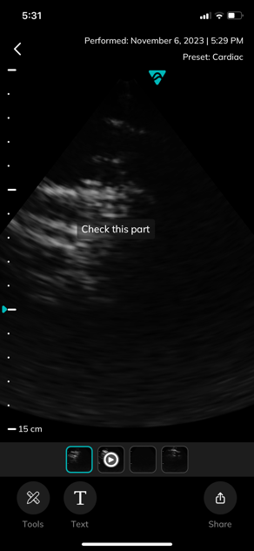  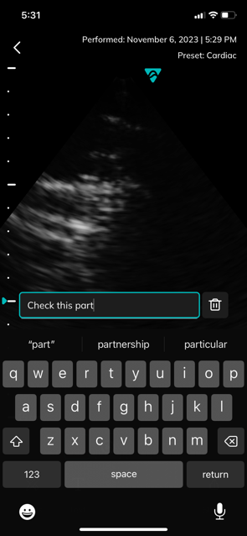  1 3

Vave Cast™
To allow others to view a live scanning session, tap the QR code icon on the scanning screen to broadcast your imaging session.
Vave Cast™ | Note  Your potential viewers will need to sign in to the Vave App to join. This allows them to view live imaging but does not allow them to make any adjustments. | 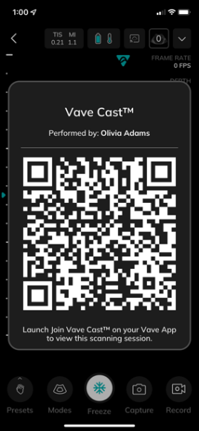

Ending an Exam
Tap the back button located in the upper left corner of the imaging screen
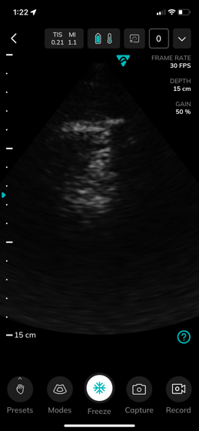 | 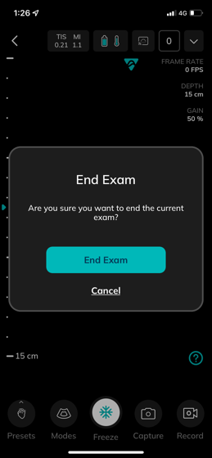

Review Findings
When you have finished imaging, evaluate, and edit the exam images and cines.
Saved Exams:
To view your saved exams, tap the Exams icon in the bottom menu from your Home screen, where you will see three sections: “My Exams”, “My Portfolio” and “My Shared”
  - My Exams – shows you all the exams that you have performed
  - My Portfolio – allows you to collect and organize ultrasound images for your “portfolio”
  - My Shared – allows you to manage the exams you have shared with others, and those others have shared with you
Each section can have several folders — tap a folder name to open and view the ultrasound images
To add a new folder, tap “+ Create New Folder" and name the folder

Reviewing Images and Cines
Go to My Exams. Tap on a specific exam, then select Gallery to view all images from that exam. In the Gallery, you can review saved images/cines — and simply tap on an image to open a detailed image view.
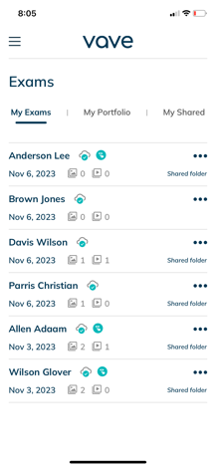 | 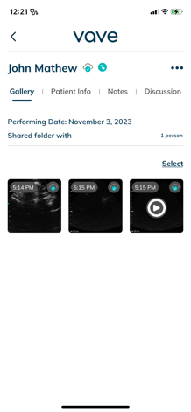 | 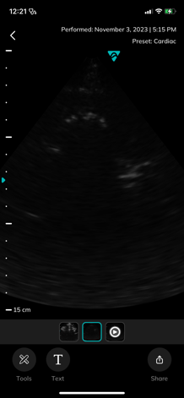

Manage Images
- To select several images/cines: tap the select option and tap the images/cines you want to select.
- To delete images/cines: select the image(s)/cine(s) and tap the trash icon.
- To export/share images/cines:
- Select the image(s)/cine(s) and tap the Share icon
- Export/share Options will appear:
  - Send via Email
  - Save Exam to my Portfolio
  - Save to Camera Roll
  - Send to PACS (if configured)
Choose your desired export option, follow the instructions, and a de-identified copy of the image will be exported:
 |  | 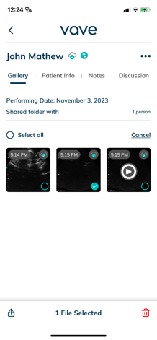 | 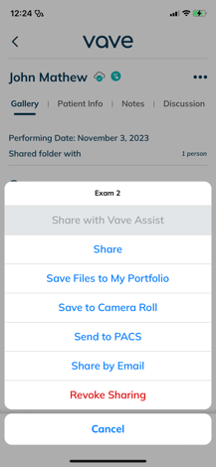

To add images/cines to a saved scan folder:
- Select the images and cines you wish to share
- Tap the Share Icon for a popup list of potential places to send the files
- Select “Save Files to My Portfolio” and select the folder where you would like to store the documents — or tap + to add a new folder.
- A de-identified copy of the images will be added to your chosen folder.

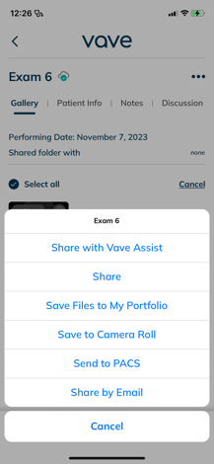
Note | Exported images will be de-identified to remove any Patient Health Information (PHI).  Make sure you follow institutional procedures regarding PHI.

Share Exams
- Tap the three dots to the right of your desired exam.
- Options to export and share your exams will appear:
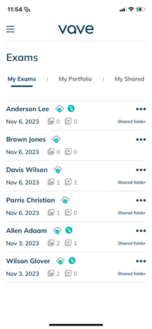 | 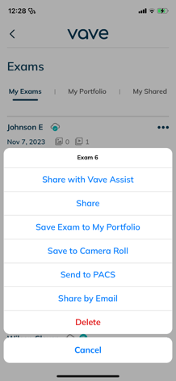 | • Share with Vave Assist  • Share  • Send via Email  • Save Exam to My Portfolio  • Save to Camera Roll  • Send to PACS  • Share by Email  • Delete

To Share:
- On the Exams screen, tap the exam you would like to share and input your recipient’s email address.
- Tap the blue “Share” button.
- You will see the response “Exam shared successfully” when complete.
- To review your shared Exams, go to the “My Shared” tab and select “Shared by me” or "Shared with me”

 | 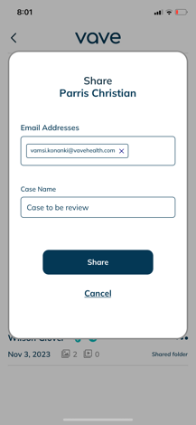 | 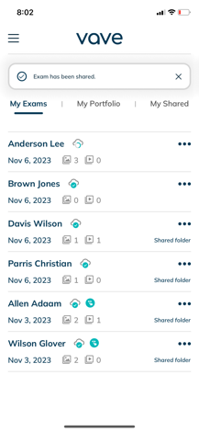

Exam Discussion
The person you share an exam with can take part in your exam discussion. To view the discussion, go to the Exams screen, tap on the specific exam, and then tap the Discussion tab.
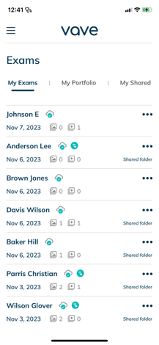 | 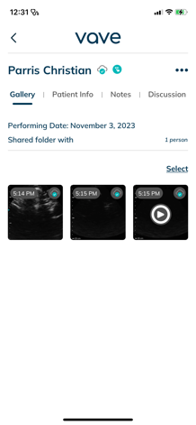 | 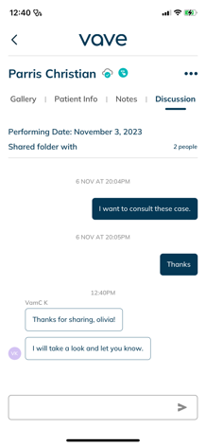

Vave Assist™ (optional)
To access Vave Assist, tap the Exams button in the lower right corner and open the exam you want to share. The "Share Exam with" icon will appear in the top right corner — just tap the icon, and the exam will be shared for feedback.
 | 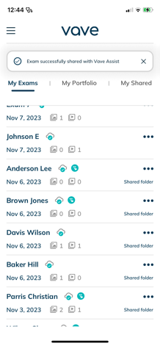 | 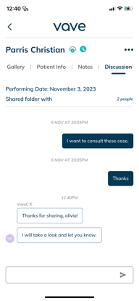

MedEd
Once you are signed in, you will see the home screen. You can see MedEd icon in top right side of home screen. Tap on MedEd icon it will navigate to MedEd page. We can start exam from assignment task list page.
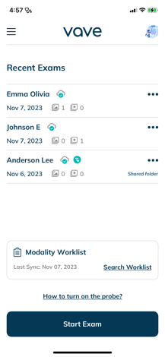 | 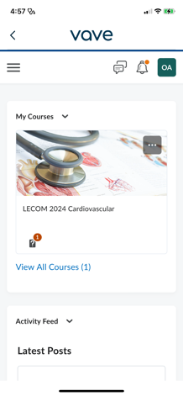 | 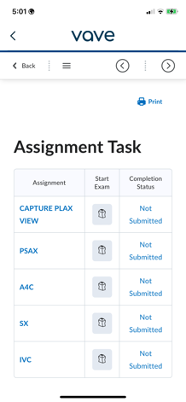

Worklist Configuration
Tap the hamburger menu ( Ξ ) at the top left of the Home screen. Once tap on dicom configuration. We can see worklist configuration. After adding AE Title, Ip address and port number we can Test worklist connection and Save Configuration.
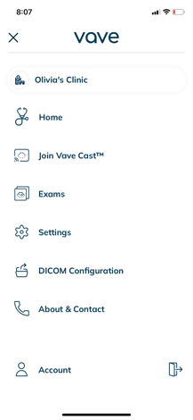 | 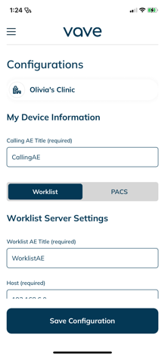 | 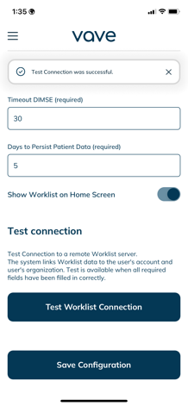

Modality Worklist
- Upon signing in, the home screen is displayed, and below the recent exam, the modality worklist widget is visible.
- Based on the worklist configuration, the search worklist button is available.
- Non-admin users are unable to configure the modality worklist.
- Admin users can see the "Configure Modality Worklist" button and can navigate to the worklist configuration page upon clicking it.
- Upon successful test worklist configuration, the "Search Worklist" button is displayed, allowing users to navigate to the Worklist page and view the patient list.
- Clicking on the expand button reveals the patient info and the "Start Exam" button.

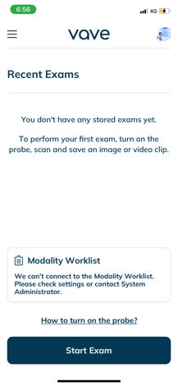 | 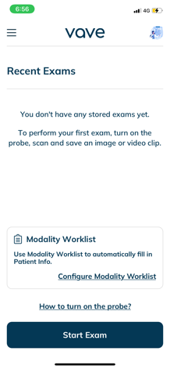 | 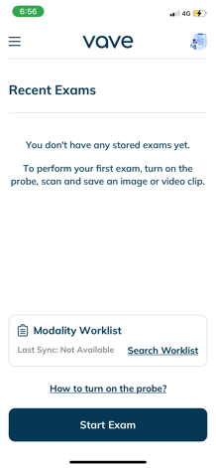 | 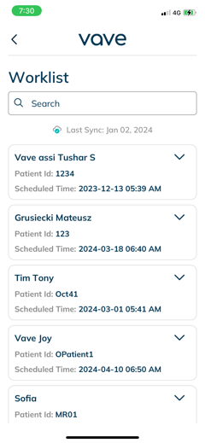 | 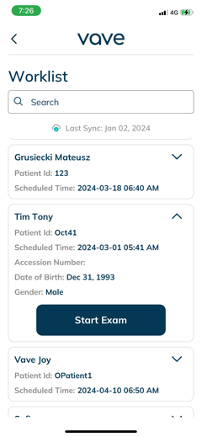

Import Modality Worklist
- After signing in, the home screen is presented, and the user can select any exam from the recent exam list.
- Navigate to the patient info tab and select the "Search Worklist" button.
- This will direct the user to the worklist screen, where the patient list is displayed.
- Upon clicking the expand button, the "Import Patient Data" button is visible, allowing the user to update patient data.

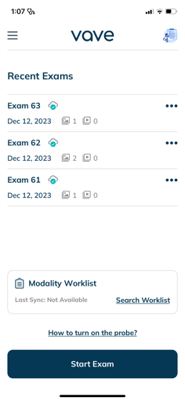 | 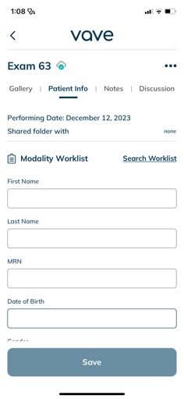 | 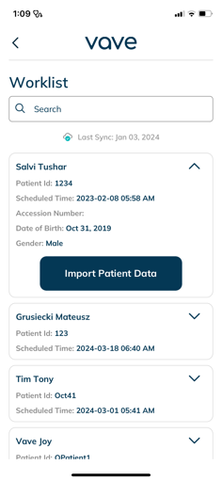 | 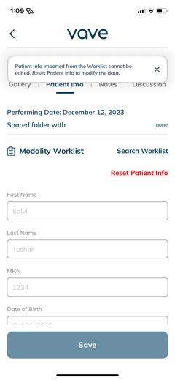 | 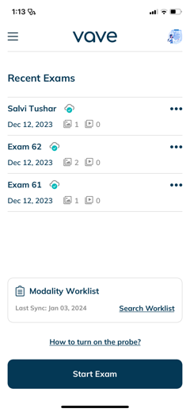

After Each Exam
Always follow these steps after completing each patient’s exam.

After Each Use
- After each use, carefully inspect the probe. Always inspect the probe before and after cleaning, disinfection, or use.
- Clean and disinfect the Vave Probe and battery.
- Clean the iOS or Android device, as required.
- Recharge the battery, as necessary.
- Store appropriately.
Warning: | The following actions may cause serious or fatal injury.  - Continuing use after the first sign or suspicion of system malfunction or defect — if suspected, contact Vave immediately.
The only maintenance required is to clean and disinfect the Vave Probe and battery.
Caution: | The system must be serviced by trained personnel only. Failing to regularly maintain or verify your Vave Probe may lead to undetected performance errors.

Cleaning and Disinfecting the Vave Probe and Battery
Caution: | - Cleaning or disinfecting the transducer while the battery is installed, may cause the battery to short-circuit and overheat, causing an electric shock or burn.  - Use only cleaning solutions approved by Vave Health, as other solutions may be incompatible and damaging  - Wear appropriate personal protective equipment (PPE), such as eyewear and gloves, as recommended  by the chemical manufacturer  - The Vave Probe is not designed for sterilization and cannot be sterilized before or between uses.

Cleaning the Vave Probe and Battery
Before cleaning, visually inspect the probe and battery for any unacceptable deterioration, such as corrosion, discoloration, pitting, or cracked seals. If any damage is evident, discontinue use and contact Vave Health.
If the device does not have visual damage, prepare the cleaning solution and follow the procedure below.
- Turn off the probe
- Remove the battery from the probe
- Use a compatible premoistened disinfectant wipe (CaviWipes™) to wipe the entire exterior of the transducer and battery separately until thoroughly cleaned
- If necessary, repeat step 3 with new cleaning material until all gel, particulate matter and bodily fluids have been removed
- After cleaning the probe and battery, wipe the exterior surface with a clean, non-abrasive, dry cloth

Cleaning the Charger
Before cleaning, visually inspect the charger for any unacceptable deterioration, such as corrosion, discoloration, pitting, or cracked seals. If any damage is evident, discontinue use and contact Vave Health.
If the device does not have visual damage, prepare the cleaning solution, and follow the procedure below.
- Unplug the charger cable from the power source.
- Disconnect the cable from the back of the charger.
- Wipe down all surfaces using a premoistened disinfectant wipe. Do not submerge the charger in any liquid.
- After cleaning the charger, wipe the exterior surface with a clean, non-abrasive, dry cloth

Disinfecting the Vave Probe and Battery
Before you begin disinfection, make sure you have cleaned the Vave Probe and battery. Next, determine the level of cleaning and disinfection required for your Vave Probe and battery, based on the Spaulding classification system listed below. Following the correct classification will help reduce cross-contamination and the spread of infection.
Each Spaulding classification mandates a specific level of cleaning and disinfection of equipment before it can be used for the next exam. Determine the Spaulding classification based on Use:
Class |  | Use | Method
Non-Critical Class |  | Touches intact skin | Cleaning followed by intermediate disinfection
Semi-Critical Class |  | Touches mucus membranes and non-intact skin | Cleaning followed by high-level disinfection (HLD)
Note | Different levels of disinfection require different steps, not just different solutions.

Intermediate-Level Disinfection
After cleaning, choose low- or intermediate-level disinfectants compatible with your Vave Probe and battery. Follow the label instructions for preparation, temperature, solution strength, and duration of contact. Make sure to remove the battery and clean the Vave Probe before beginning disinfection.
- Use a compatible premoistened disinfectant wipe (CaviWipes™) to wipe the probe and battery separately for 1 minute
- Air-dry the probe and battery or towel-dry with a clean, non-linting cloth
- Examine the probe and battery for any damage, such as cracks or splitting where fluid can enter — if any damage is evident, discontinue use and contact Vave Health

High-Level Disinfection
If the Vave Probe has come into contact with broken skin, mucosal membranes, or blood, you must perform high-level disinfection. Make sure you have removed the battery and cleaned the Vave Probe before beginning.
- Check the expiration date and prepare the disinfectant solution following the label instructions
for solution strength and disinfection duration
- Using the disinfectant CIDEX® OPA, at a temperature of 23°C (73°F), immerse the probe
and the battery separately in the undiluted disinfectant solution for the required duration
- Rinse the probe and battery using the instructions on the disinfectant label
- Air-dry the probe and battery or towel-dry with a clean, non-linting cloth
- Examine the probe for any damage, such as cracks or splitting where fluid can enter — if damage
is evident, discontinue use of the probe and contact Vave Health.

After cleaning and disinfecting the probe and battery, let them air dry and then wipe down the exterior surfaces with a clean, non-abrasive, dry cloth.

Cleaners and Disinfectants
The following table lists the cleaners and disinfectants compatible with your Vave Probe and accessories.
The products listed in the following table are chemically compatible and have been tested for efficacy.

Level of Disinfection | Solution | Active Ingredients | Usage
Low Level | CaviWipes™ | Alcohol, Quarternary Ammonia | Wipe – Follow manufacturer’s instructions
High Level | Cidex® OPA | Ortho-phthalaldehyde | Soak – Follow manufacturer’s instructions

You may also use products not specifically listed in the compatibility table but with similar active ingredients and marketed for medical use. Because of the large number of available cleaners and disinfectants, it is impossible to have an all-inclusive list. If you are unsure of the suitability of a particular product, contact Vave Health for more information.

Recharging the Battery
Please refer to Charging the Battery
- Connect the line cord of the AC power adapter to an indoor electrical outlet
- Connect the AC power adapter to the receptacle on the battery charger
- Note that the charger LED toggles between yellow and green when power is applied
- Remove the battery from the Vave Probe by following the instructions on Removing the Battery, below
- Insert the battery into a slot on the battery charger
- The LED will stay yellow when the battery is charging
- The LED will stay green when the battery is fully charged
for instructions.
Note | - Because the Vave Probe is battery-operated, you must recharge the battery when necessary. An empty battery takes approximately 4 hours to fully charge. Once fully charged, a battery has approximately 2 hours of typical scanning time.  - Charge the battery using only the specified charger. Connecting the battery charger to a power supply not manufactured by Vave may expose the battery to the incorrect voltage/current, which could damage the battery charger.  - Do not charge the battery while on board an aircraft. Charging the battery in a rotary-wing airborne ambulance may cause the battery charger’s power supply to interfere with the aircraft’s electrical system.  - The battery power level of the Vave Probe is displayed in the Vave App when the probe is connected to your smart device. When the battery reaches a charge level equal to less than 10 minutes of residual scanning time, a visual warning is presented to the user.

Storing the Vave Probe
To protect your Vave Probe:
- Dry thoroughly before storage
- Avoid storing in extreme temperatures
- Avoid placing under direct sunlight for prolonged periods of time, as it may discolor the housing’s finish but will not impact the Vave Probe’s safety and performance
- Store separately from other equipment. Refer to the “Environmental Operating, Transient and Storage Conditions” section in Chapter 5.

Troubleshooting the Vave Probe
Use the table below to identify and understand alerts displayed in the Vave interface.
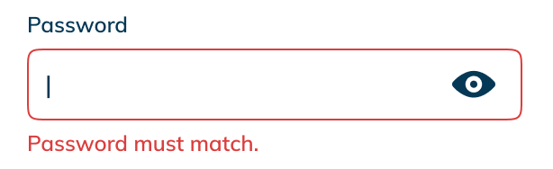 | Password Error  If you do not enter the correct password, you will be prompted to try again to enter the correct password.
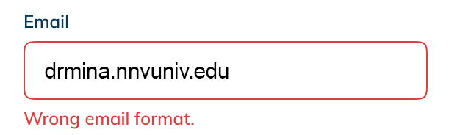 | Wrong Email Format  You’ll see this warning when the email address you entered is not typed with an “@” symbol or does not meet internet email format standards.
 | Sign-in Failure  This alert will appear if you submitted a password doesn’t match the email address you entered —or if no account has been created with the email address you entered.
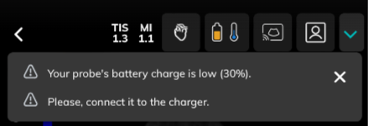 | Low Battery  If your probe is running out of battery power, a low battery alert will appear on top of the screen.
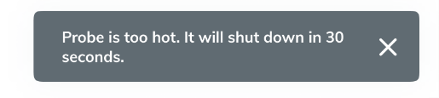 | Temperature Alerts  To protect your device, the probe’s software will alert you to potential overheating, and if the probe gets too hot, it will give you a 30-second warning before automatically shutting down.
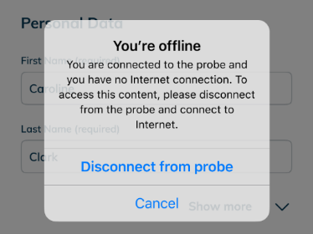 | No Wi-Fi  This alert shows up if you are not connected to the internet when trying to register new probe.
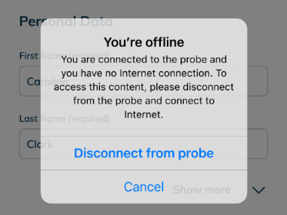 | Required Update  If there is a required update for the probe available, you will see a required update alert.
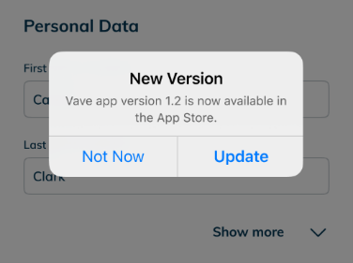 | Optional Update  If there is an optional update for the probe available, you will see an optional update alert.
Unable to connect to probe | Ensure that the battery is fully charged before attempting to connect to the probe.
OTA update not able to complete | Ensure that the battery is fully charged before attempting an OTA (over the air) software update on the probe.

Additional Help
For Support, tap the hamburger menu ( Ξ ) in the upper left corner of the screen. There you can access the User Manual, a video Walkthrough, Privacy and Policy, Terms of Services and Frequently Asked Questions (FAQs):

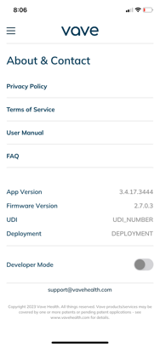 | If you require additional assistance,  please contact Vave Health at  www.vavehealth.com

System Setup and Administrator’s Guide

Account Creating, Signing In and Out

Creating An Account
This task is performed by a Vave Administrator. Please contact Vave Health for more information.

Register/Sign-In with Invitation Link
If your account is being set up or provisioned by your organization's administrator, you will receive an email with a link inviting you to register or sign-in to your account. Simply follow the link to finish creating your profile.

Signing In
To sign in, open your App and enter your email and Password.

Signing Out
You can log out of your account at any time from your profile settings page.
Note | You will be automatically signed out after 30 days.

Forgotten Password
- To reset your password, enter the email address you used to sign up and tap the “Continue” button
- When the app prompts you to enter your password, tap the “Forgot password?” link, then enter your email address and tap “Continue” to receive your verification code
- Now go to your email account and copy the verification code
- Enter the verification code in the app and create your new password
- Your new password is set — just reenter it one more time to proceed

Organizations
If you are affiliated with an organization for which you perform ultrasound exams, your organization's Administrator will need to add you as a member.
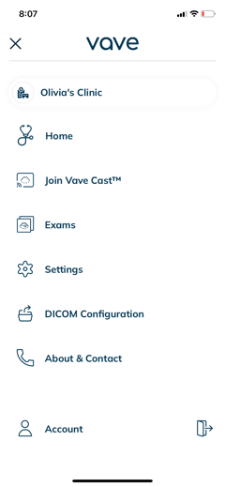 | 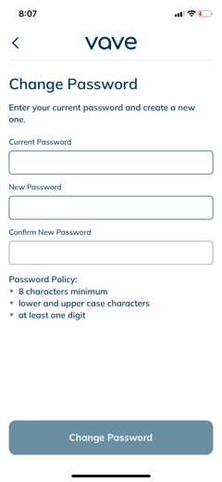 | - If you belong to multiple organizations, you can switch between them by tapping the hamburger menu ( Ξ ) at the top left of the Home screen  - Exams are tied to the organization selected when scanning  - When you change organizations, you will only see Exams cataloged for that organization

Managing Patient Information

Entering Patient Information
You can enter Patient Information either during a scanning session by selecting the Patient Icon on the top menu or in the Exams tab by selecting the “Patient Info” section in the Exams detail screen.
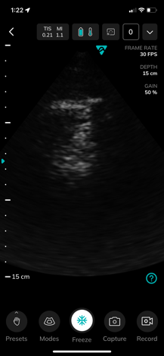 | 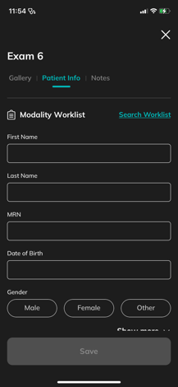 |  |  | 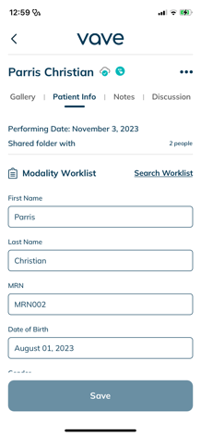

Please make sure that you entered the correct patient information and always be sure to follow your institution’s policies regarding Patient Health Information.

Settings

Profile Settings
From the Home screen, you can tap on the user avatar in the upper-right corner to open profile settings. There, you can change your profile, log out of your account, or reset your password. You can also change your avatar by uploading an image/photo. The email address is tied to an account and cannot be changed by the user. To use a new email, you will need to create a new account.
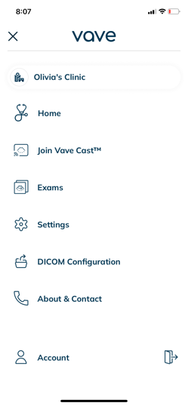 | 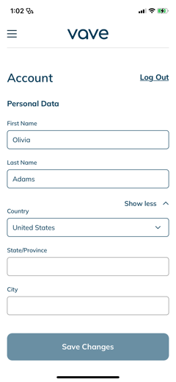 | 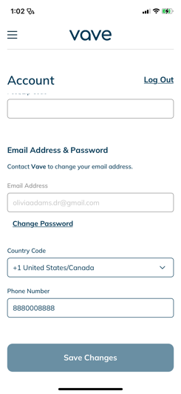

Settings
You can access the Settings menu panel by tapping the hamburger menu ( Ξ ) in the top left corner. On the side menu:
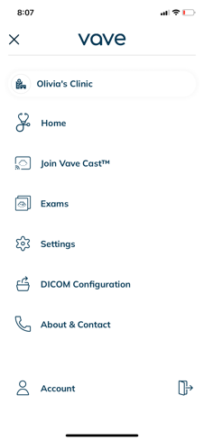 | - Home  - Join Vave Cast™  - Exams  - Settings  - Dicom Configuration  - About & Contact  - Account  - Profile Settings

Join Vave Cast™
This allows you to view someone else's Vave Cast session. At the beginning of a session, a QR code will be displayed on the scanning screen. Simply position your device's camera over the QR code and tap accept to start viewing their screen. This is a view-only mode, so you will not be able to adjust the image.
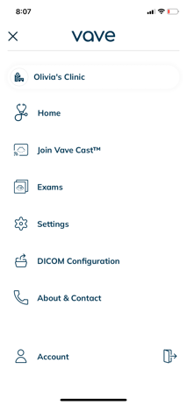 | 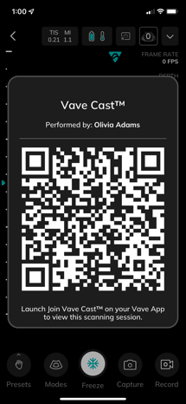 | 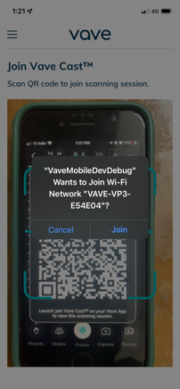 | 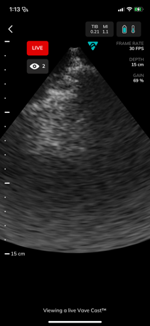 | 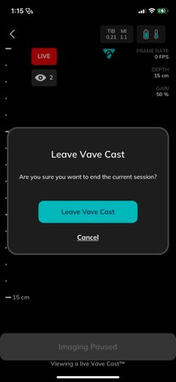

PACS Configuration
You can select an existing PACS configuration or set up a new one — to set up a new one, you will need to contact your Organization Admin to get the Organization IP Address and Port Number.
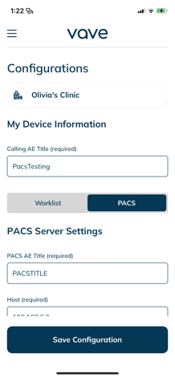 | 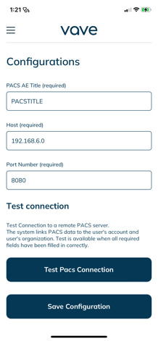

Imaging Settings
You can adjust the Cardiac Probe Marker Orientation and the Cine Length:
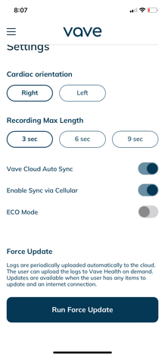 | 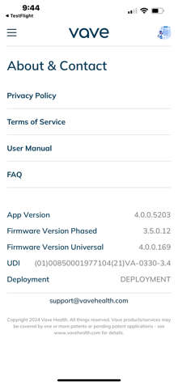 | • Cardiac Orientation: By default, the probe marker on the ultrasound image for the cardiac preset is on the right side. Here you can change the probe marker to the left side.  •  Recording Max Length: The dropdown menu gives you the option to adjust the time a forward recorded cine will be recorded by number of frames.  In the About Section, you can view your App version and Firmware version (if connected to your Vave probe).

Vave Cloud™
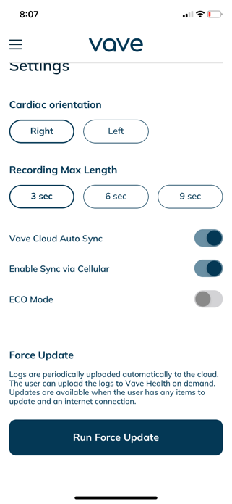 | - Data Backup which is enabled through the automatic syncing of exams to the Vave Cloud  - Images you acquire are automatically uploaded and synced to the Vave cloud by default  - On Demand Download: To download an image/cine, need to click on Download cloud button available near Exam name  - If you wish to disable automatic image uploading and sync, you may turn off Vave Cloud Sync in Sync Settings  - Note: When Cloud Sync is disabled, you cannot access powerful features such as exam discussion, sharing, etc.  - ECO Mode: ECO Mode reduces performance during B-Mode imaging in cardiac preset to 20 FPS instead 30 FPS for better battery life and thermal management.

Vave Web Portal Guide for Administrators

Web Portal User Interface Layout and Usage
The Vave Web Portal enables you to manage all organizations, probes and exams that are synced to the cloud. There are four levels: Vave Admin, Organization Administrator, Regular User, and All.
Figure 3.1: Web Portal User Interface Layout

Item | Usage
 | User, Role, Administrative Functional Categories: Organization, Users, Probes, Exams, Scanning Activity, Profile
 | Screen Navigation Controls
 | Organization Name
Actions that can be taken as an administrator, i.e., “delete,”, “edit,” etc. Click on the Ellipses to bring up a list of actions.
Other actions appear throughout the screen as button boxes, i.e., “Create User,” “Add Member,” “Add Probe,” “Create Folder,” “Share Exam,” etc.
 | Tabs listing additional functionality for each Administrative Category. Organization: General Information, Members, Probes, PACS Configuration. Exams: My Exams, My Portfolio, My Shared. Scanning Activity.
 | Lists Organizations, Members, Users, Probes, Exams, Scanning Activity, Image Gallery, or Exams
 | Pop-up Action or Confirmation of Action (i.e., “Delete”) Menu
 | Discussion box
 | Exam Details

Administrative Tasks

Creating an Organization (Vave Administrator Task)
This task is performed by a Vave Administrator. Please contact Vave Health for more information.

Managing an Organization
To manage an organization, click the ellipsis (…) in the row of the organization you would like to change. A drop-down menu appears that allows you to Edit or Delete the organization. In the Edit Organization dialog box, you can also change the organization’s name and profile picture.
To change the organizations details, click the Edit button (when you click on Organizations in the side menu, the General Information tab displays).
To remove the Organization, click the Delete button.
On the right, the number of Membership Seats is shown for each plan, along with the renewal date for Plus Memberships. Basic memberships do not have an expiration date

Adding a Member
To add an existing Vave Health App user to an organization, click on the Add Member button and enter the new member’s email address from their account and then allocate their Membership Seat.

Editing a Member’s Status
To edit a member’s status, click the ellipsis (…) at the right of the member’s row to Remove from Organization, Revoke Admin Rights, or to Change Membership.

Creating a Probe (Vave Administrator Task)
Probes need to be created/deleted by a Vave Admin before they appear on the Web Portal. Please contact Vave Health for more information.

Managing an Organization’s Probes
To view all probes attached to the current organization, click the Probes tab.
To add a probe, click the Add Probe button in the upper right corner and select the new probe’s serial number from the drop-down list. Organization Admins cannot add a probe to the portal, but an Organization Admin can add probes to the organization where they can be used by members in that organization to perform exams.
To remove a probe from an organization, click on the Remove button on the probe line in the probe listing, then conform removal by clicking the Remove button on the Remove Probe from Organization dialog box.

Creating a New User
To create a new User, click the Create User button in the upper right corner and enter information about the User (only the user’s email is required; the rest of the fields are optional).

Managing Users
To manage users (add/modify/delete), click on Users in the side menu, then click the ellipsis (…) at the right of a User’s row and a drop-down menu appears that allows you to open the Edit User dialog box and update the user’s details.
To view a user’s details, click the name in the User’s list to display Personal Data, Email, and Organization membership.
To update a member’s status (Remove from Organization, Revoke Admin Rights, or Change Membership), click the ellipsis (…) to the right of an Organization.
To add a user to an Organization/Multiple Organizations, click the Add Organization button.
To remove a user from an Organization, click the ellipsis (…) on the row of the organization you want to remove and select Remove from the drop-down menu.

Managing Exams (Discussion and Exam Details)
To display all exams that are synced to the cloud, click Exams in the side menu. The My Exams tab shows all exams that you performed. Beneath that tab, you can select exams you wish to view from the drop-down menu, by organization. From there, you can share, rename, and delete exams by clicking the ellipsis (…).
To display more details of an exam, click on a single exam row. You can view all the files (images and cines) that are included in each exam. On the right, there is a record of any Discussion around that exam where you can add comments and share them with others regarding the exam. You can edit and view Patient Data and Notes in the Exam Details module, located below the Discussion.
To edit Patient Data, click Patient Data tab and then click the Edit button in the Exams Details module, then press Save.
To edit Notes, click the Notes tab and then click the Edit button to access the Edit Exam Notes dialog box where you can update exam notes as needed, then press Save.
To enlarge an image for review, click on the image you want to see for an expanded view.

Managing Images and Cines
To display the images and cines that you have collected in folders, click the My Portfolio tab.
To create a new folder location for saved images and cines, click the Create Folder button, name the folder, then click Save.
To share folders, click the Share Folder button in the upper right corner, enter the email of the person you want to share the folder with, then press Save.
To revoke a share, click the Revoke Sharing button above the Shared With drop-down list, select the revoke, then confirm by clicking Revoke on the Revoke Sharing dialog box.
Note | Anyone with whom you shared the package loses access to these files when you select Revoke Sharing. These files will be deleted from their portals. You cannot undo this action.
To manage (rename and delete) folders, click on the folder name, then choose to Rename Folder, Delete Folder, or Share Folder.
To view and participate in a shared discussion of the images in this Portfolio Folder, review the Discussion module.

Managing Exam Folders
To see all your shared packages of files, click the My Shared tab. To see items that other Vave Health users have shared with you, click on Shared with Me. To see item(s) you have shared with other Vave Health users, click on Shared by Me.
To delete single exam files, select each file you wish to delete – a check mark appears in the lower left next to each thumbnail indicating your selection(s) – then, click the Delete button to complete the action.

Sharing Exams
To share an exam with someone, click the Share Exam button in the upper right corner, then enter the email(s) of the person(s) you want to share the exam with. By default, the name of the package you are sharing appears in the Note field, where you can type in a message to your recipient.
Note | Shared Exams are automatically de-identified so they do not reveal any sensitive Patient Health Information (PHI). Pleae be certain you follow your organization’s PHI protocols.

Copying Exams
Copying Exams to My Portfolio:
Select the images you want to copy, click Copy Exams to My Portfolio, then select the folder in your portfolio where you would like to copy the images.
Copying Exams from One Folder to Another Folder:
Select the files in the folder in My Portfolio, then copy them to another folder.
Or create a New Folder, and then copy the files there after typing in a new folder name.

Managing Your Profile
To view and edit your profile information (Personal Data, Scanning Activity, Email, Password, Organizations you belong to, and List of Devices you have used to log into), click Profile in the side menu.

Resetting Your Password
To reset your password, click the Reset Password in the upper right corner.

Viewing Activity
To view your scanning activity, and the scanning activity of all members that belong to your organization, click Scanning Activity.

Administrator Screen layouts are shown below.

Organizations
Admins can view, edit, and delete organizations under their management from this menu.
Figure 3.2: Organizations Page
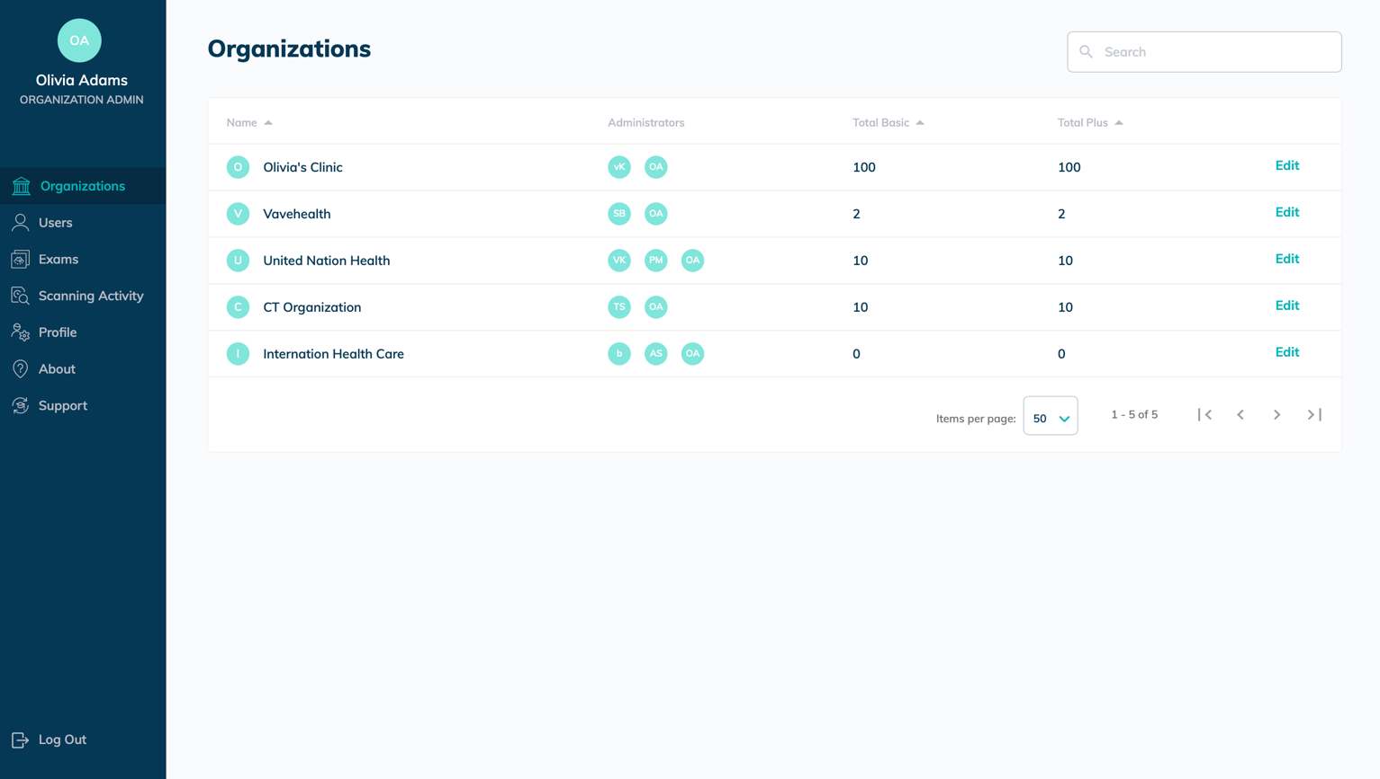

Available Actions:
- Edit (change organization name and profile picture)
- Delete

General Information Page
Organization Details: Contact Information, Membership Seats. Renewal date for Plus Memberships. Basic memberships do not have an expiration date.
Figure 3.3: General Information Page
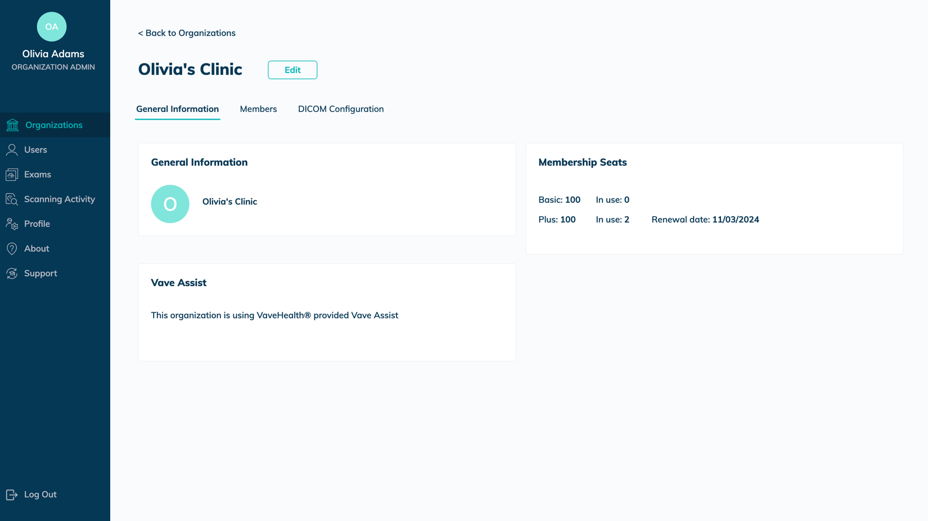
Available Actions:
- Edit Organization
- Delete (removes the Organization)

Members
Displays all the members in that organization.
Figure 3.4: Members Page
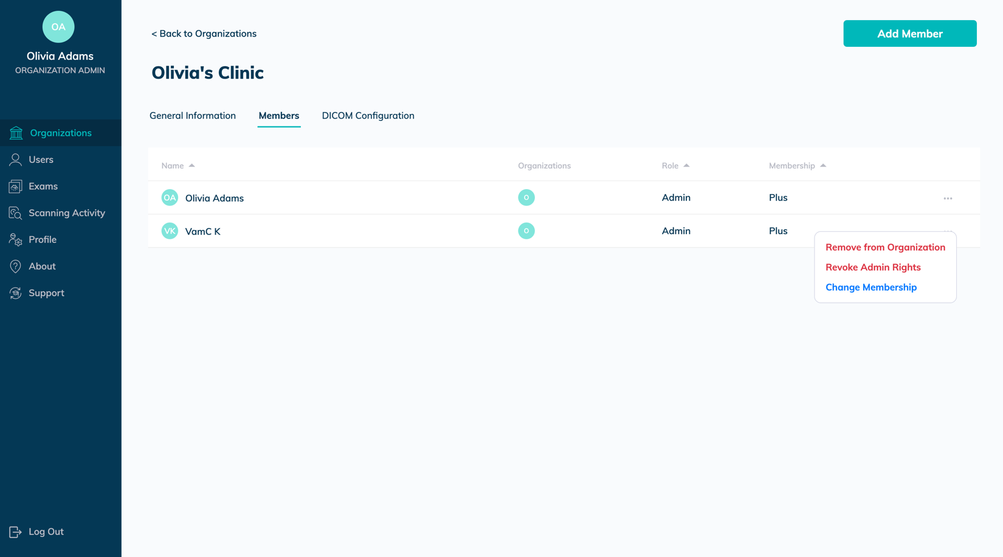
Available Actions:
- Add Member (Add new member’s email address, then allocate their Membership Seat)
- Remove from Organization
- Revoke Admin Rights
- Change Membership

PACS Configuration
Contact Vave Health to configure PACS.

Users
Manage users within an organization.
Figure 3.5: Users Page
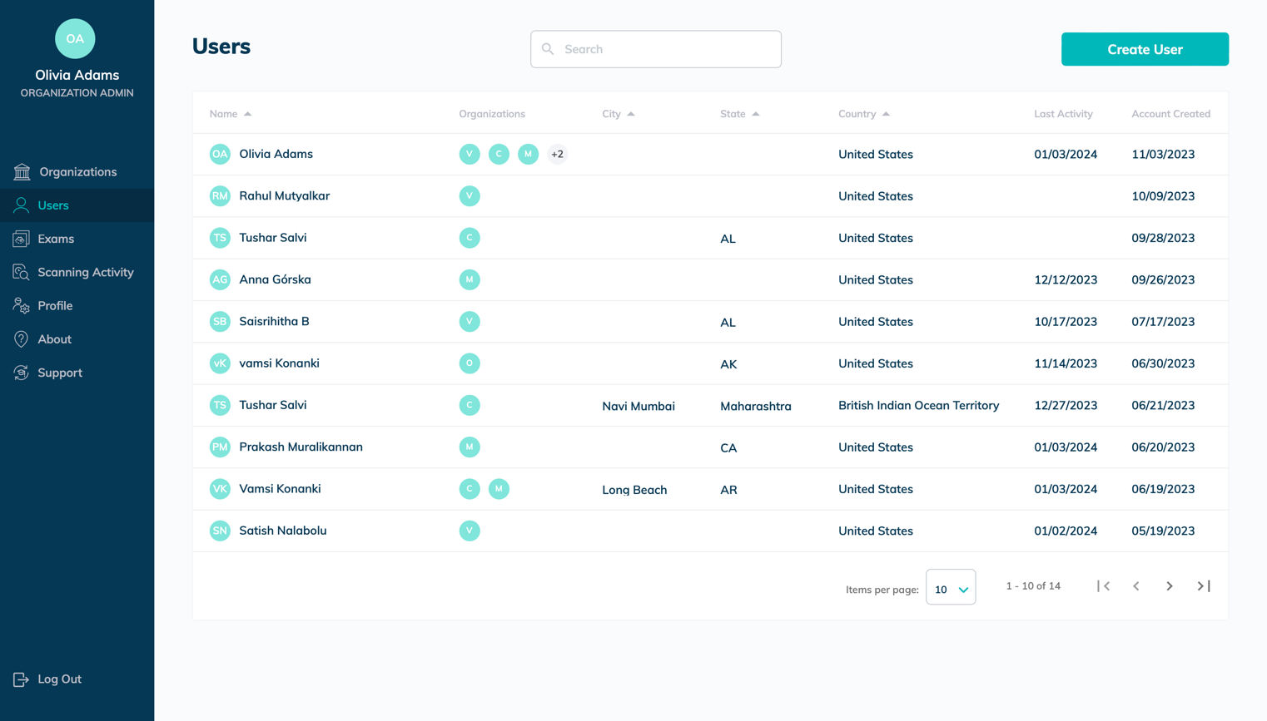
Available Actions:
- Create User (user’s email required)
- View User’s Details (click on the user’s name)
- Edit User
- Add to Organization(s)
- Remove from Organization(s)
- Revoke Admin Rights
- Change Membership

Exams
My Exams, My Portfolio, and My Shared. Click on the image you want to see for an expanded view.

My Exams
Shows all exams that you performed.
d
Figure 3.6: My Exams Page, Expanded Image View Page
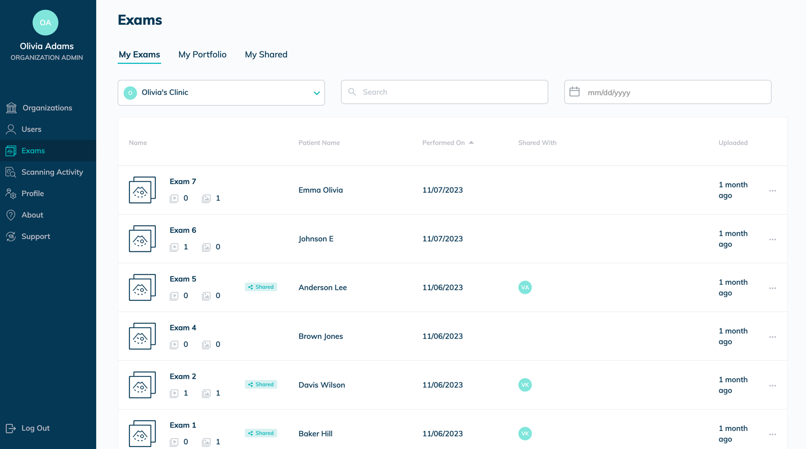

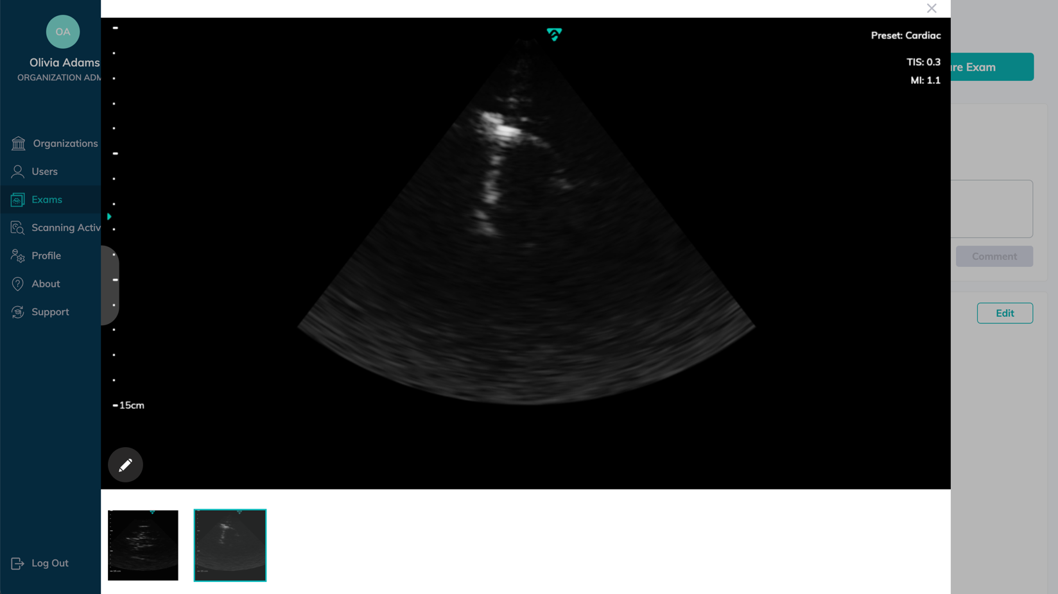
Available Actions:
- View Details (click on the exam’s name) of all images and cines in each exam, Patient Data, Notes, and any Discussion around that exam.
- Edit Patient Data
- Edit Exam Notes (click on Notes Tab, then click Edit)
- Rename Exam
- Share Exam
- Delete Exam
Note | You can delete single exam files. Select each file you wish to delete – a checkmark appears on each thumbnail to be deleted.)

My Portfolio
Displays the images and cines that you have collected in folders.
Note |  | Clicking on a folder name allows you to review its contents, which is similar to My Exams, but without the patient data and notes from the exams.
Figure 3.7: My Portfolio Page
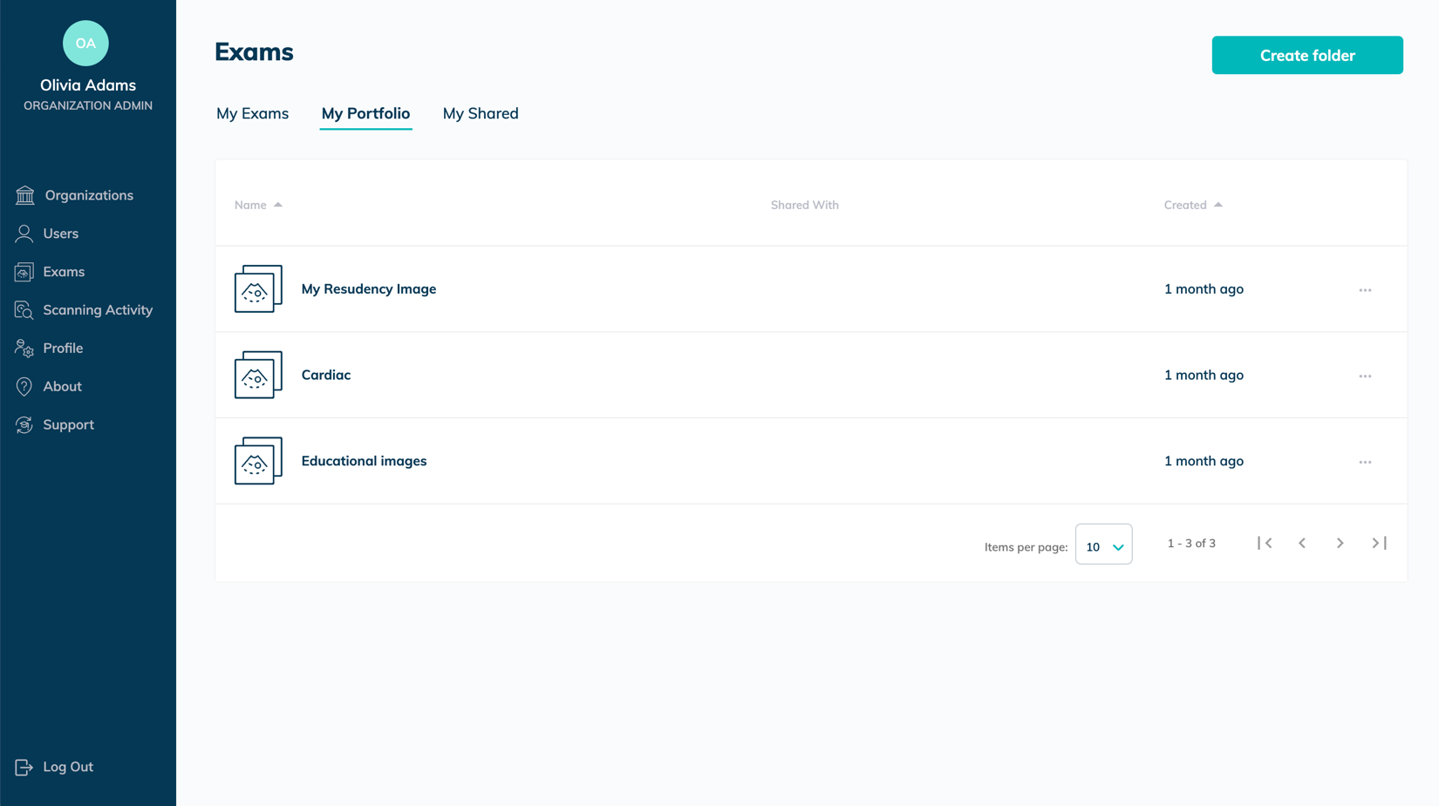
Available Actions:
- Create Folder (to save images)
- Rename Folder
- Share Folder
- Copy Files
- Delete Folder
- Discussion Module (You can view and participate in a shared discussion of the images in this Portfolio Folder.)

Figure 3.8: Copying Exams to My Portfolio Example
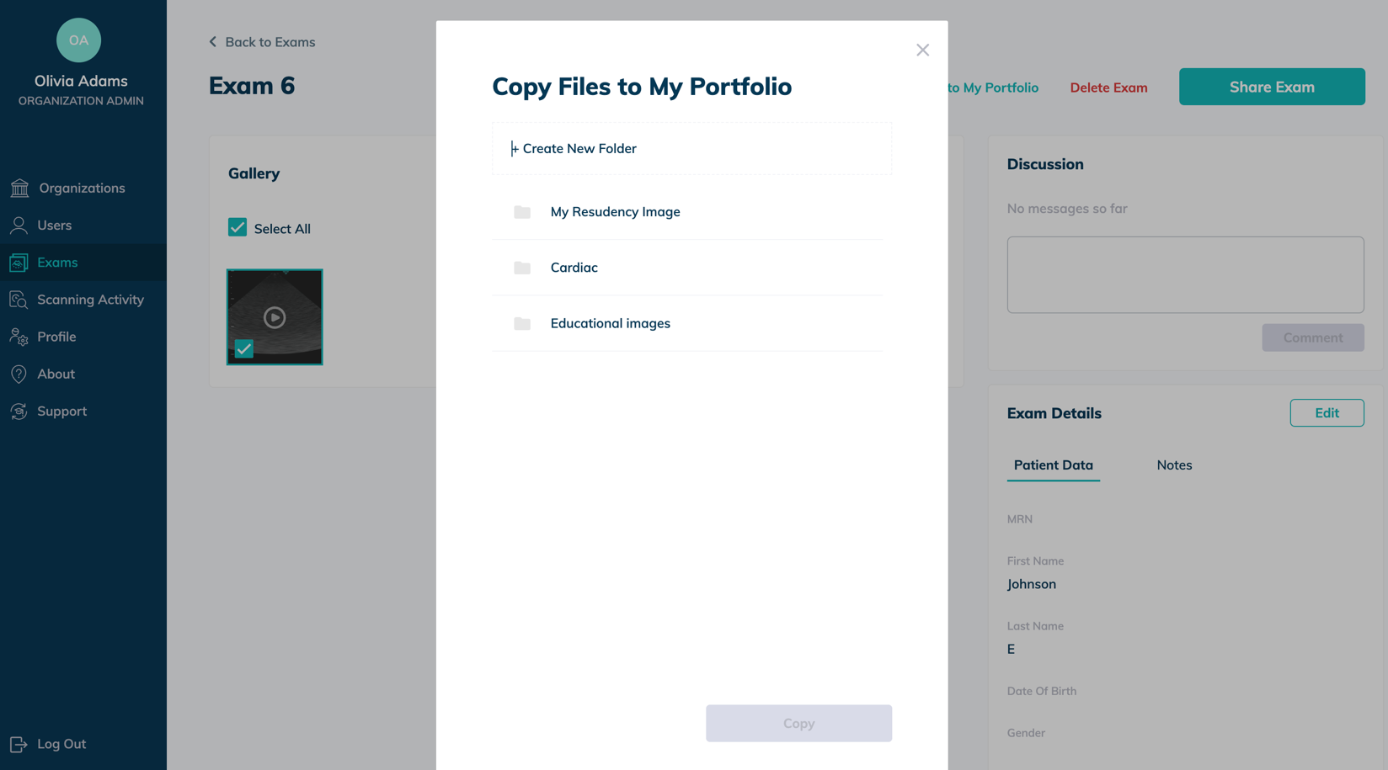

My Shared
Shared by Me (Displays items you have shared with other Vave Health users.)
- Shared with Me (Displays items other Vave Health users have shared with you.)
- Shared by Me (Displays items you have shared with other Vave Health users.)
Important Note |  | Shared Exams are automatically de-identified so they do not reveal any sensitive Patient Health Information (PHI). Please be certain you follow your organization’s PHI protocols.
Figure 3.9: My Shared Page
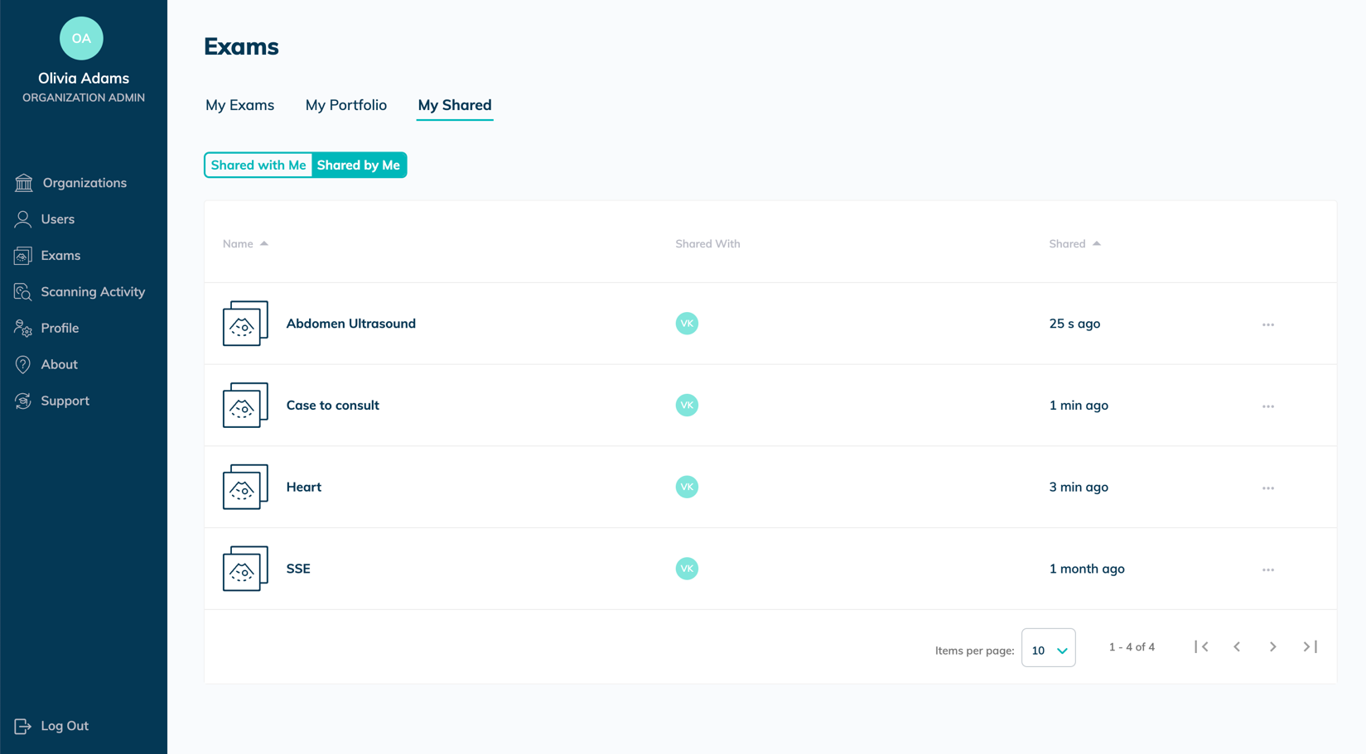
Available Actions:
- Share with more people (Enter email of person you want to share the exam with. The name of the package you are sharing appears in the “Note” field, where you can type in a message to the recipient.)
Note | Once an exam has been shared, you can share with more people and manage sharing options
- Revoke sharing (Select the name of the revoke from the drop-down list).

Note | You cannot undo this action. Anyone with whom you shared the package will lose access to these files, and these files will also be deleted from their portals.

Profile
Your profile contains Personal Data, Scanning Activity, Email, Password, Organizations you belong to, and a list of devices you have used to log in.
Figure 3.10: Profile Page
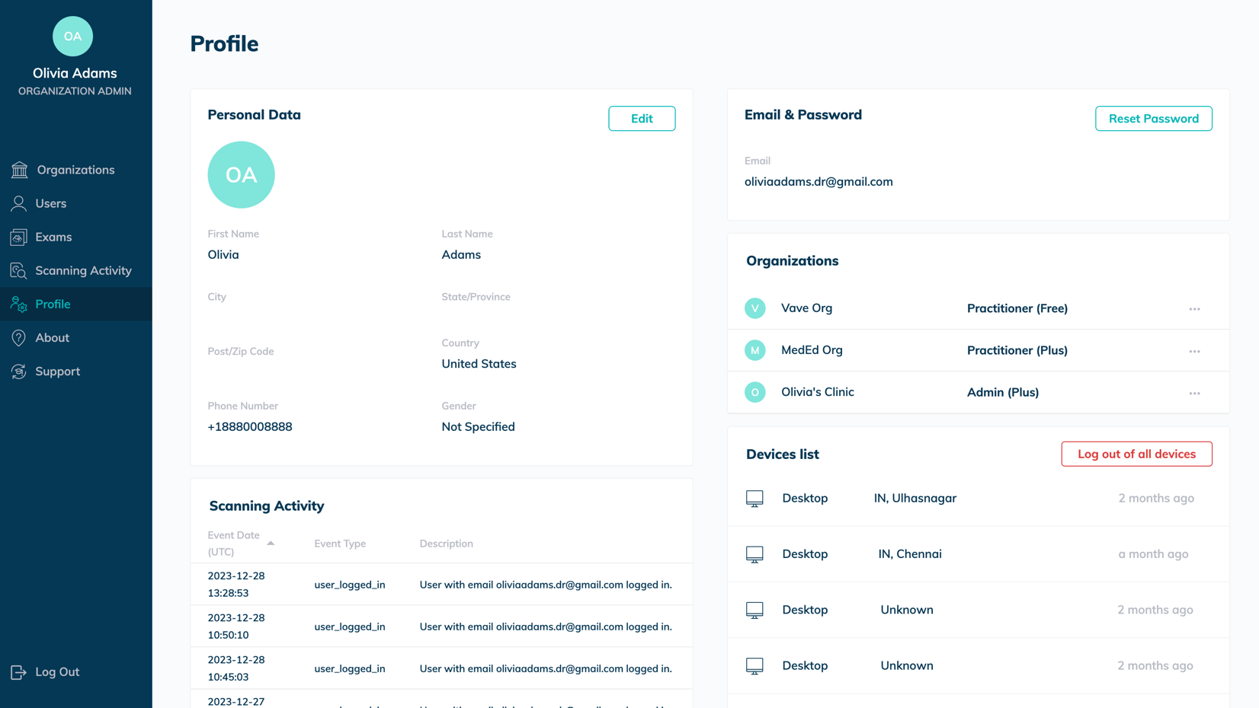
Available Actions:
- View Profile
- Edit Profile
- Reset Password (Click on Reset Password button.)

Scanning Activity
One can view their own activity and the activity of all members that belong to your organizations.

Figure 3.11: Scanning Activity Page
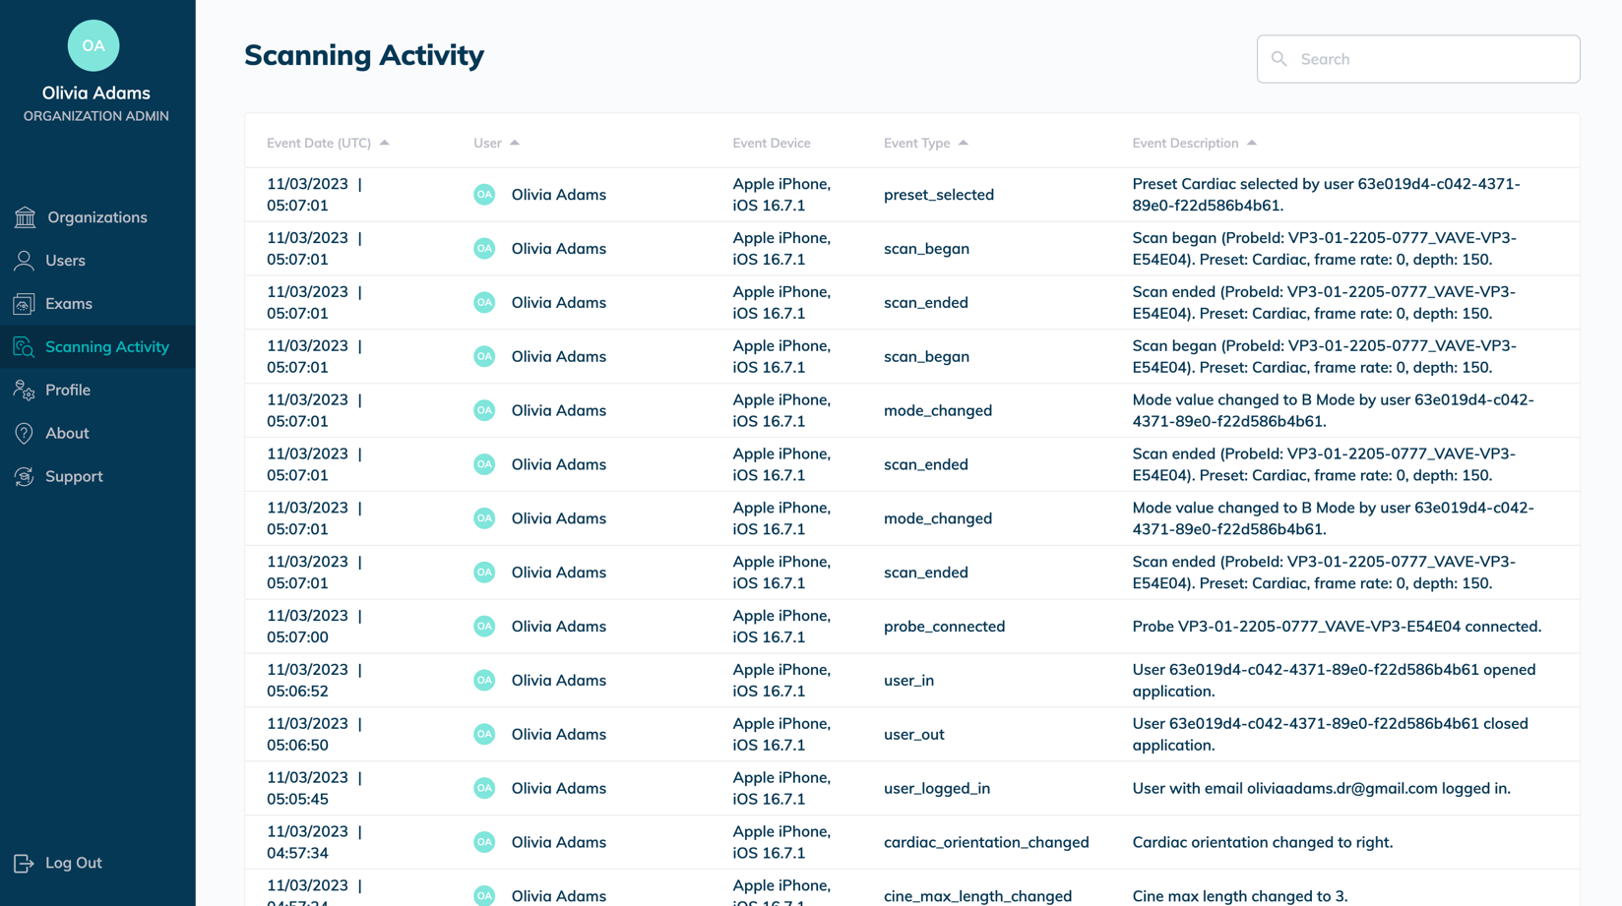
Available Actions:
- View Activity (users and members of their organization)

About and Support
About: Privacy Policy, Terms of Service, and Firmware Version.
Support: User Manual and Frequently Asked Questions

Worklist and PACS Configuration
One can view the organization screen and click on any organization. You will find the worklist and PACS configuration.

Figure 3.12: Worklist and PACS configuration
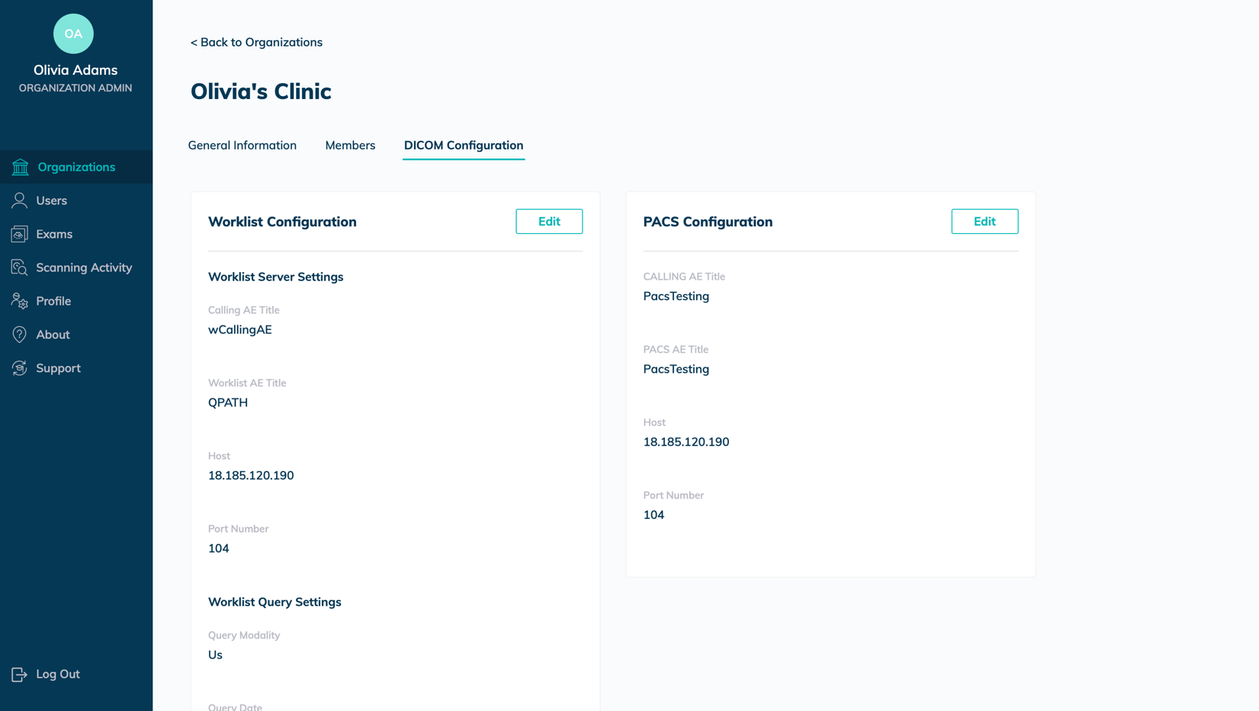

Product Safety
These instructions describe how to use the Vave Probe and App safely. These two safety levels note two types of safety information:
Danger:  Warning:  Caution: | A danger indicates information critical to safe operation, noting where a severe or substantial hazard may exist to the operator or to the patient through improper use or conditions, resulting in fatal personal injury or significant property damage.  A warning indicates information critical to safe operation, noting where a severe or substantial hazard may exist to the operator or to the patient through improper use or conditions, resulting in significant personal injury or significant property damage  A caution indicates information critical to safe operation, noting where a potential hazard may exist to the operator or to the patient through improper use or conditions, resulting in minor injury or minor property damage.

Diagnostic Ultrasound Imaging
Diagnostic ultrasound is a non-invasive technique used to generate images inside the body. Ultrasound probes, or transducers, produce sound waves at a high frequency (above 20KHz) and then detect ultrasound echoes that are sent back. When echoes reach the transducer, the resulting electrical signals are recorded on an ultrasound scanner. The return echoes calculate the distance between the transducer and the tissue’s boundary. These recorded distances create a two-dimensional image of body tissues.
During an exam, ultrasound gel is applied to the skin to prevent pockets of air from forming between the transducer and the skin. Air pockets can inhibit ultrasound waves entering the body.
Some of the clinical uses for ultrasound include imaging of the heart, lungs, blood vessels, fetus, thyroid, breast, brain, abdominal organs, pelvic organs, skin and muscles. Ultrasound can also be used to help guide movements in minimally invasive surgeries or guide the insertion of a catheter into a blood vessel.

Ultrasound principles of operation
The transducer generates high frequency sound waves that pulsate along a narrow beam in one direction. It also acts as a microphone, receiving echoes generated by tissue the beam encounters. These returning ultrasound waves generate an electrical signal that is transferred and displayed on the screen in real-time as an image.

Ultrasound exams
Unlike many medical radiation tools, ultrasound uses non-ionizing radiation, which means it does not come with many of the same risks associated with other radiation imaging techniques. Numerous epidemiological ultrasound studies have indicated there is no causal relationship between any known negative effects and exposure to diagnostic ultrasounds of this type (Ziskin & Petitti, 1988; Barnett et al., 2000).

Ultrasound biological interactions
Ultrasound imaging is considered safe, but ultrasound energy does have the potential to produce biological effects. During an ultrasound exam, the ultrasound waves may warm tissues in the body. In some cases, this warming may even produce pockets of gas in bodily fluids or tissues. The long-term consequences of these biological effects are not yet known. For these reasons, many organizations have advocated for carefully regulated use of ultrasounds during pregnancy. Any use of ultrasound imaging for non-medical purposes is strongly discouraged.

Important Safety Warnings
This section covers general safety information. Safety information applicable to specific tasks or functions is noted throughout the manual.
The Vave Wireless Ultrasound is intended for use by trained healthcare professionals. Do not use the Vave Wireless Ultrasound unless you have read and understand the instructions in this manual and all of the information in this section. Operating the system without proper safety awareness could lead to fatal or serious personal injury.

Patient, Personnel, and Product Safety
The safety of connected mobile devices is the user’s responsibility. Always read and follow the safety guidelines for your smart device.

Product Warnings
Warning: The following actions may cause serious or fatal injury
- Operating the Vave Probe without proper training on use and safety.
- Attempting to remove, modify or override any element of the system, especially safety features.
- Using the system with any product not specifically recognized as compatible with the Vave Probe.
- Continuing use after the first sign or suspicion of system malfunction or defect — if suspected, contact Vave immediately.
- Using the system for anything beyond its intended use.
Warning: Product Compatibility
The Vave Probe includes a battery, battery charger and a power supply for the charger. Do not use your Vave Probe or Vave Battery Charger with other products or components made by another manufacturer, unless approved by Vave.
Modifications to the Vave Wireless Ultrasound can only be made only by Vave or by third parties approved by Vave. Any modification must comply with applicable country and regional regulations and laws.
Modifications made using unapproved parts or made without appropriate training, may cause personal injury, or damage the system.
Warning: Notifications and alerts from third-party applications
Notifications and alerts from third-party applications may interrupt you or the Vave Health App, thereby interfering with the exam.
- If the vibration range is too high, this may cause the scanner to malfunction during an exam.
Warning: Using an improper gel type or combining gel types
Using an improper gel type of combining gel types may pose patient risks and produce poor-quality images — for proper transmission of the acoustic beam, use only Aquasonic 100, prior to its expiration date. Download and read Aquasonic 100 usage instructions from www.parkerlabs.com before operating the device.
Do not use:
- Lotion-based products or gels containing mineral oil
- Hand-sanitizing gels
- Scanners left soaking in gel

Warning: Battery Safety
If the battery performance appears abnormal during use, while being recharged, or after being stored, emits an odor, is warm/hot to the touch, discolored, or malformed, discontinue use and contact Vave immediately.
Replace the battery if it fails to charge fully.
When disposing of the battery, dispose of in accordance with local custom or facility requirements. Do not discard the battery by fire. Contact Vave Health if further information is required.
The following actions may damage the battery:
- Using or charging the battery near a heat source
- Touching battery contacts
- Opening, crushing, puncturing, or short-circuiting contacts
- Connecting the positive and negative terminals directly to metal objects
- Using the battery in temperatures below -20°C (-4°F) or above 60°C (140°F)
- Charging the battery in temperatures below 10°C (50°F) or above 45°C (113°F)
- Forcing the battery into the system. The polarity of the battery terminals is fixed and cannot be reversed.
- Connecting the battery to an electrical power outlet
- Charging the battery using non-Vave equipment
- Leaving the battery in direct sunlight
Warning: Maximum Probe Temperature
The system limit for patient contact temperature is 43°C (109°F). The Vave probe will shut down to prevent overheating.

Biopsy Safety
Warning: Biopsy Safety
The needle must be visible when performing a biopsy procedure.
- Verify the needle’s position – needles can bend upon insertion.
- Be aware that reverberation or other tissue artifacts may cause a false needle image.

Electrical Safety
Electrical Safety
- Before use, carefully inspect the probe. Always inspect the probe before and after cleaning, disinfection, or use. Visually inspect the probe face and housing. If damaged, cracked, chipped, or torn, discontinue use and contact Vave Health.
- Remove probe from the patient before applying high-voltage defibrillation.
- Do not use with pacemaker as high-frequency signals may interfere with a pacemaker.
- Do not connect accessories unapproved by Vave as these could result in electrical shock and/or increased emissions.
- The Vave probe is susceptible to RF interference as Electrosurgical units (ESUs) and other scanners intentionally introduce RF electromagnetic fields (currents) into patients.
- Do not use scanners with high-frequency surgical equipment. A burn hazard may result as the Vave probe has no means of shielding someone from a defect in the high-frequency surgical neutral electrode connection.
Warning: Defibrillator Safety
Do not use with Defibrillator. BEFORE defibrillation, remove any part of the system that is in contact with the patient.

Electromagnetic safety
Electromagnetic Safety
The Vave Wireless Ultrasound uses wireless technology to communicate with your iOS/Android device. Wireless communication may be subject to disruption by severe weather conditions and radio frequency interference. Without impacting the safety of the Vave Wireless Ultrasound, the captured image may show signs of unwanted. The Vave Wireless Ultrasound is designed to minimize these affects but may not eliminate them entirely.
Electromagnetic Compatibility
The Vave Probe is compatible with existing electromagnetic requirements and complies with electromagnetic compatibility standards. This compliance provides reasonable protection against harmful interference in a typical medical installation.
Review the environment where you use the Vave Wireless Ultrasound frequently to ensure that the presence of an electromagnetic field is not causing degraded image quality.
Electrostatic Discharge (ESD) Precautions
Electrostatic discharge (ESD), or static shock, results from the flow of an electrical charge from a person/object of a higher charge to that of a lower charge. ESD is found in low-humidity environments (caused by heating or air-conditioning).
To reduce ESD:
- Use anti-static spray.
- Use a ground wire connection between the Vave Probe and the patient table/bed.
- Do not touch the connector pins on the battery.

Electromagnetic Emissions
System performance may be degraded.
Ensure that the Vave Wireless Ultrasound is used only in those operating environments indicated in the following table.

Declaration of Electromagnetic Emissions
Figure 4.1: Electromagnetic Emissions Compliance
Emission Test | Compliance | Electromagnetic Environment
RF emissions, CISPR 11 | Group 1, Class B | The system uses RF energy for its internal function and for wireless communication in the ISM bands. Therefore, its RF emissions outside the ISM bands are very low and are not likely to cause any interference in nearby electronic equipment.
Magnetic Effects, RTCA DO-160G Section 15.0 | Equipment Category Z
Radiated RF Emissions, RTCA DO-160G Section 21.5 | Equipment Category M
Harmonic Emissions, EN/IEC 61000-3-2 | Not applicable | Power Line/Signal Line testing is not applicable since the system is a portable device with no signal cables.
Voltage Fluctuations/Flicker Emissions, EN/IEC 61000-3-3 | Not applicable

Electromagnetic Immunity
Figure 4.2: Immunity Test, Test Level, and Compliance Level
Immunity Test | IEC 60601-1-2 Test Level | Compliance Level
ESD  EN/IEC 61000-4-2 | +/-2kV, +/-4kV, +/-6kV, +/-8kV Contact  +/-2kV, +/-4kV, +/-8kV, +/-15kV Air | +/-2kV, +/-4kV, +/-6kV, +/-8kV Contact  +/-2kV, +/-4kV, +/-8kV, +/-15kV Air
Radiated, radio frequency electromagnetic field immunity  EN/IEC 61000-4-3 | 10 V/m, 2 Hz modulation  10 V/m, 1 kHz modulation | 10 V/m, 2 Hz modulation  10 V/m, 1 kHz modulation
Power frequency magnetic field immunity test  EN/IEC 61000-4-8 | 30 A/m, 50 Hz frequency range  30 A/m, 60 Hz frequency range | 30 A/m, 50 Hz frequency range  30 A/m, 60 Hz frequency range

Electromagnetic Interference (EMI)
The impact of electromagnetic interference (EMI) from other equipment upon the Vave Wireless Ultrasound is depending upon the system’s operating mode, image control settings, and the type and level of electromagnetic interference -- which may be intermittent and difficult to locate the source.

Caution: EMI may disrupt the image quality, use caution, and relocate the system as necessary.

Possible causes of electrostatic interference:
- ESD caused by charge buildup on insulated surfaces or persons.
- RF energy from portable phones, hand-held radios, smart devices, commercial radio, and TV stations.

Questions to ask when trying to locate sources of RF interference:
- Is the interference intermittent or constant?
- Does the interference show up only with one scanner or with several scanners?
- Is the interference present if the system is moved to a different location in the facility?
- What other electronic devices are in the vicinity of the scanner, i.e., printer, other smart devices, radio, TV, etc.?

Recommended Separation Distance
The table below provides guidance on conducted and radiated interference from portable and fixed RF transmitting equipment and recommended separation distances between the system and any RF-transmitting equipment. Follow the recommended separation distance to reduce the risk of interference. Ensure compliance for each frequency range, as noted in the table.
Figure 4.3: Recommended Separation Distances by Transmitter Frequency
Rated Maximum Output Power of Transmitter (Watts) | 80 to 2700 MHz | 5.2 GHz to 5.8 GHz
0.1 | -- | 15.2 m (49.9 ft)
2.2 | 3 m (9.8 ft) | --

For example, if a portable transmitter has a maximum radiated power of 2.2W and an operating frequency of 384 MHz, it can be operated at distances greater than 3 m (9.8 ft) from the system.

Biological Safety

Allergic Reactions
Allergic Reaction: Latex Safety
Contact with natural rubber latex may cause a severe anaphylactic reaction.
The Vave Probe does not contain any natural rubber latex. However, be aware of other instances of items containing latex (probe covers, gloves, etc.). Ensure you read the package labeling to determine latex content.

Bioeffects
Bioeffects
- Thermal (TI): Thermal bioeffects refers to the heat created by ultrasound energy and tissue’s absorption characteristics:
- TIB -- Bone: Dense bone absorbs energy very quickly, which causes the temperature to rise.
- TIS -- Soft tissue: Soft tissue absorption varies by organ. The tissue density within a particular organ is also not always the same.
- Mechanical (MI): Mechanical bioeffects, such as cavitation, occur when output exceeds a certain level. This threshold varies depending on tissue type.
References:
- EN/IEC 60601-2-37 – Medical electrical equipment. Part 2-37: Particular requirements for the safety of ultrasonic medical diagnostic and monitoring equipment.
- EN/IEC 62359: Test methods for the determination of thermal and mechanical indices related to medical diagnostic ultrasound fields.
- FDA guidance document “Information for Manufacturers Seeking Marketing Clearance of Diagnostic Ultrasound Systems and Scanners,” September 2008.

ALARA Principles
Alara Principles
ALARA Principle (As Low As Reasonably Achievable)
According to ALARA, ultrasound usage should be limited to the lowest acoustic output for the shortest duration of time. The ultrasound user should consider the type of patient, exam type, patient history, difficulty in retrieving the required information, and the potential of localized heating due to transducer surface temperatures.
Additional considerations:
- Minimize scan time by performing only medically required ultrasound scans
- Use diagnostic ultrasounds efficiently and effectively
- Select the correct scanner application

ALARA Training Reference:
The American Institute of Ultrasound in Medicine provides training in the Medical Ultrasound Safety booklet. This training provides principles of basic ultrasound, possible biological effects, derivation, and significance of the indices, and ALARA principles with examples. It is acceptable to the FDA as an effective ALARA educational program. More information can be found here:
In the US: by telephone at 1-800-638-5352
By mail:
AIUM
14750 Sweitzer Lane, Suite 100
Laurel, MD, USA 20707-5908

Output Display
Output Display
The output display provides the user with an indication of the potential for. With this information, users can ensure that diagnostic information is obtained with minimal risk to the patient. Always practice ALARA.
Display Standards (TI Display/MI Display)
The system output display consists of the following exposure indices to indicate the potential thermal and mechanical effects:
- TI: This is continuously displayed over the range of 0.0 to maximum output, based on the application, in increments of 0.1, and consists of the following indices:
– Approximate index for the application: TIS is used for imaging soft tissue, TIB for a focus at or near bone.
- MI: This is continuously displayed over the range of 0.0 to 1.9, in increments of 0.1.

Display Accuracy
The MI and TI have a precision of 0.1 unit on the system. Estimates of the MI and TI display accuracies are shown in the Acoustic Output Tables.

Controls Affecting Display Indices
Acoustic output defaults are set when you select an application. Factory defaults vary by application. Default settings have been chosen below the FDA limits for intended use. Use system controls to change the TI and MI values. When a new imaging mode is selected, both the TI and MI may change to default settings. The system will return to the previously selected settings if a mode is turned off and then reselected.
B-Mode Controls
- Focus: When the focal depth is near the natural focus of the scanner, the MI may be higher.
- Zoom: Increasing the zoom magnification by spreading the display may increase frame rate, thereby increasing the TI. The number of focal zones may also increase automatically to improve resolution. This action may change the MI, because the peak MI can occur at a different depth.
- Depth: An increase in two-dimensional depth will automatically decrease the B-Mode frame rate, thereby decreasing the TI. The system may also automatically choose a deeper two-dimensional focal depth. A change of focal depth may change the MI.

Acoustic Power
Acoustic Power
The system limits acoustic output values to their respective U.S. Food and Drug Administration limits. In an over-current condition, the scanner is shut off immediately.
Acoustic Measurement Precision and Uncertainty
All table entries have been obtained at the same operating conditions that result in the maximum index value in the first column of the tables. Values for measurement precision and uncertainty are listed in the following tables for power, pressure, intensity, and center frequency. Measurement precision on the following quantities is determined by making repeated measurements and stating the standard deviation as a percentage.
Figure 4.4: Acoustic Measurement Precision and Uncertainty
 | Precision | Uncertainty  (Percentage, 95% Confidence Value)
Pr | <1% | +/- 8.4%
Wo | 7.6% | +/- 16.8%
fc | <1% | < +/- 1%
PII.3 | 2.8% | +/- 16.2%
Notes :
Pr=the underrated peak rarefactional pressure measured in megapascals (MPa)
Wo=the ultrasonic power in milliwatts (mW)
Fc=the center frequency in megahertz (MHz) (NEMA UD-2 definition)
PII.3=the derated spatial-peak pulse intensity integral in joules per square centimeter (j/cm2)

Device Labels
Device Labels
These symbols are included in our product literature and industrial design in compliance with ISO and IEC regulatory standards. Please consult the table below for each symbol and its meaning.
Figure 4.5: Labels: Probe, Battery, Battery Charger and Probe Box
Probe - Phased Battery Charger Probe Box - Phased
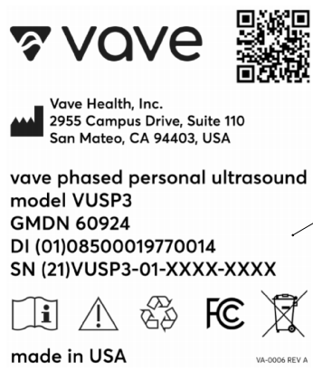

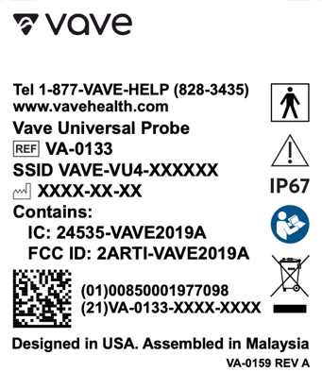
Probe - Universal Probe Box - Universal
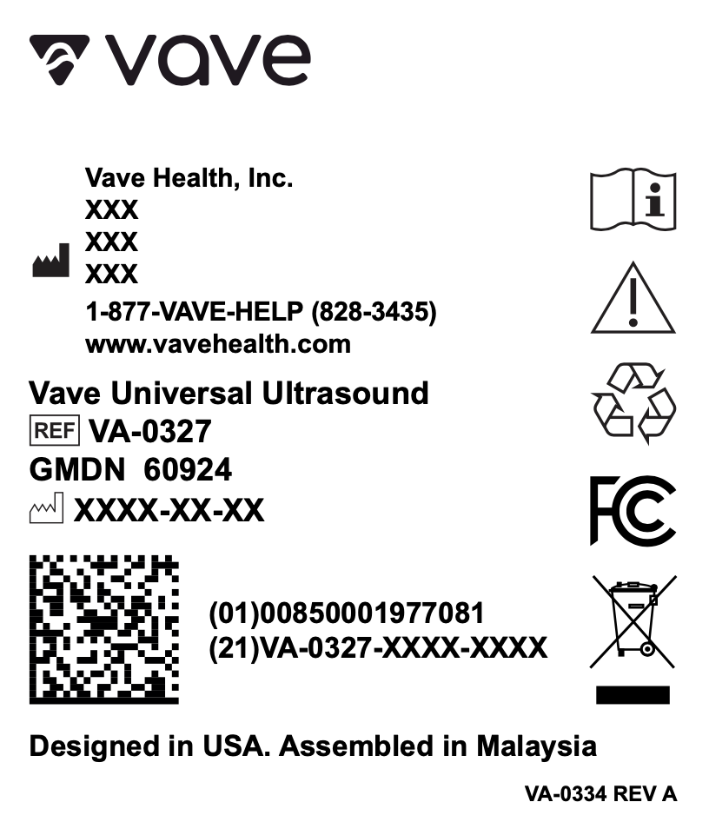

Label | Label Identifier and Purpose
 | Company name and logo.
 | QR Code
Legal Medical Device Manufacturer’s name and address. ISO 7000-3082

Country and Date of Manufacture (United States). IEC 60417-6049

or | Model Number. IEC 60417-6050 – or -  Serial Number. ISO 7000-2498
 | Type BF Applied Part (man in the box) symbol. IEC 60417-5333
 | To indicate that caution is necessary when operating the device or control close to where the symbol is placed, or to indicate that the current situation needs operator awareness or operator action in order to avoid undesirable consequences. ISO 7000-0434A
 | The Vave Ultrasound Scanner and Battery can be completely submerged up to 1 meter in water. IEC 60529
 | Indicates the need for the user to consult the instructions for use. ISO 7000-1641
 | This WEEE symbol indicates that waste electrical and electronic equipment must not be disposed of as unsorted municipal waste and must be collected separately. Please contact an authorized representative of the manufacturer for information concerning the decommissioning of your equipment. Standard: EN 50419
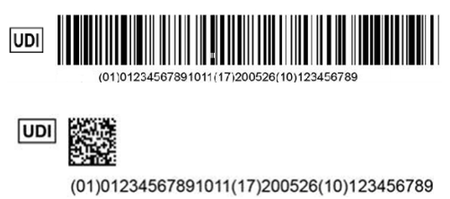 | Unique Device Identifier (UDI).  Indicates a carrier that contains Unique Device Identifier information
 | Recycle according to local custom and regulation.
 | Battery Charger
 | Class II Equipment. IEC 60417-5172
 | Federal Communications Commission Identification number. IC ID The Canadian certification ID number relating to radio apparatus and broadcasting equipment. FCC Part 15: Sub-part CRSS-247
 | Indicates the temperature limits to which the medical device can be safely exposed. ISO 7000-0632
 | Indicates the range of humidity to which the medical device can be safely exposed. ISO 7000-0224

Specifications and References

Compliance Statement
The Vave Wireless Ultrasound system complies with national standards and laws. Users are responsible for ensuring that the chosen mobile device and probe are compliant with the law in the jurisdiction where the product is used. Vave Health meets all regulatory standards listed in this chapter.

The Vave Wireless Ultrasound System

Product Classification
- Device with probes (internally powered ME equipment): US FDA: Class II
- Scanners: Type BF applied parts, IP67
- Battery: IP67
- Ordinary Equipment/Continuous Operation
- Non-AP/APG

Product Model Number
The model reference for the Vave Wireless Ultrasound system, components, or accessories will consist of a 3-character alphanumeric:
Figure 5.1: Product Model Number
Product Name | Model Number Reference
Vave Wireless Ultrasound | VUSP
Vave Phased Probe | VP3
Vave Universal Probe | VU4
Vave App | VUA
Vave Battery | VBT
Vave Battery Charger | VCG
Probe Cap | VCP
Lanyard | VLN

Each probe has a unique serial number assigned, which is used to track quality control. The following format of the serial number will be used:
The following format will be used for the production identifier: <7 character part number>-<2-digit year and 2-digit week>-<4-digit running number>
- Example: VA-0182-2408-0001
- The 4-digit running number will reset to 0001 when the number reaches 9999.

System Specifications
Conforms the following specifications:
- Gray shades: (256) in B-Mode

Environmental operating, transient and storage conditions
These are the environmental conditions that are acceptable for transport and storage of the Vave Probe
between uses:
Figure 5.2: Environmental Conditions
 | Operating Limits | Transient Operating Limits (1) | Storage Limits
Pressure | 620 hPa to 1060 hPa | n/a | n/a
Humidity | 15% to 90% non-condensing | 15% to 90% non-condensing | 5% to 90% non-condensing
Temperature | 0°C (+32°F) to + 40°C (+104°F) | -20°C (-4°F) to + 50°C (+122°F) | -40°C (-40°F) to + 70°C (+158°F)

(1) The conditions under which the scanner can operate, for at least 20 minutes, immediately after being removed from an environment of 20°C (60°F).
If stored or transported in conditions outside what’s stated above, the scanner may degrade in performance or become unusable.
If the probe has been in an environment above 40°C (104°F), allow to cool to operating temperature before turning on or operating — approximately 25 minutes depending on length of temperature exposure. Do not allow the transducer to contact the patient if the temperature of the transducer is higher than 43°C (109°F).
The Vave Probe automatically shuts down if the probe surfaces other than the patient contact area reach a temperature of 48°C (118°F). The patient contact area will not exceed 43°C (109°F) during operation. If the scanner reaches its maximum surface temperature, it automatically shuts down.
The temperature icon:
- Blue: indicates that the scanner is cool.
- Orange: indicates that the scanner is heating up
- Red: it indicates that the scanner is too warm.
If the probe has been in an environment below 0°C (32°F), allow to reach operating temperature before turning on or operating — approximately 20 minutes depending on length of temperature exposure. Condensation inside the devices could cause damage.

System Dimensions
Figure 5.3: System Dimensions
 | System Dimensions
Vave Phased Probe | Dimensions: 169 x 54 x 38 mm (including battery)  Weight: 205 g (without battery)  Frequency Range: 1.5 MHz to 3.5 MHz
Vave Universal Probe | Dimensions: 166 x 54 x 38 mm (including battery)  Weight: 220 g (without battery)  Frequency Range: 2 MHz to 6 MHz
Vave Battery | Dimensions: 83.4 x 54 x 21.8 mm  Weight: 115 g
Vave Charger | Dimensions: 104 x 59.9 x 44.9 mm  Weight 130 g

Accessories
The following two accessories are provided as part of the Vave Wireless Ultrasound Solution (one battery and one battery charger per system). If you would like to purchase additional batteries or chargers, please contact Vave Health.
Before you begin using your Vave Battery or Battery Charger, clean and disinfect it according to the Cleaning and Disinfecting instructions in Chapter 2.
Figure 5.4: Accessories
Accessory | Description
Battery | The Vave Battery is a removable Li-ion battery, rechargeable only through the Vave Battery Charger. The battery is rated for IP67 and has been tested to IEC 62133 to ensure patient and operator safety.
Battery Charger | The Vave Battery Charger is a charging unit exclusively intended to charge the Vave Battery. The charger consists of electronic components that control the charge profile and an LED light to indicate the charging status of the battery.  The battery charger unit includes an off-the-shelf, medical-grade AC/DC wall adapter. The battery charger has been tested to IEC 60601-1 and IEC 60601-1-2 to ensure patient and operator safety.

iOS/Android Specifications
Caution:
Using the Vave Wireless Ultrasound with a smart device that does not meet the minimum requirements may result in low-quality images, unexpected results, and possible misdiagnoses.

iOS Devices:
Minimum Device Requirements
• Operating System: iOS 15+
• Processor: CPU: A10+
• Technical Features: GPU: PowerVR Series 7+. RAM: 2 GB+
Recommended Requirements
• Operating System: iOS 17
• Processor: CPU: A11+
• Technical Features: Apple GPU. RAM: 3 GB+

Android Devices
Minimum Device Requirements
• Operating System: Android™ 11+
• Processor: CPU: Quad-core+
• Technical Features: GPU: Dedicated GPU. RAM: 3 GB+
Recommended Requirements
• Operating System: Android™ 14
• Processor: CPU: Octa-core
• Technical Features: GPU: Dedicated GPU. RAM: 3 GB+

Note: Please read the FAQ page on the Vave Health website for the list of devices and operating systems on which this application was tested.

Battery Specifications
The Vave Probe contains a removable lithium-ion battery. The battery is charged through the provided charger.

Battery Specifications:
Figure 5.5: Battery Specifications
Battery Specifications | Description
Battery Manufacturer | Vave Health, Inc.
Battery Type/Chemistry | Lithium ion
Battery Model Number | VBT
Battery Management | Fuel gauge with protection circuitry and temperature monitoring
Battery Life | 500 cycles
Charger | Input: 100-240 Vac, 50/60 Hz, 1.0-0.6 A Output: 12 VDC, 2.5 A
Battery | 3.6 V/7000 mAh
Charge Time | < 12 hours from an empty battery to full charge
Scan Time | Over 1 hour of continuous operation in B-Mode

Hardware
Figure 5.6: Hardware Warranty and Disposal
Warranty/Disposal | Hardware
Warranty | Your Vave Probe includes a minimum one-year warranty. See https://www.vavehealth.com for current information.
Disposal | Vave Probe and Accessories can be environmentally hazardous if improperly disposed. Please follow all local, state, and federal regulations and dispose of according to local custom.

Standards

Biocompatibility
ANSI/ISO 10993-1:2009 — Biological evaluation of medical devices — Part 1: Evaluation and testing within a risk management process.

Electrical Safety
The Vave Wireless Ultrasound System has been evaluated, tested, and found to meet the applicable requirements of the following international safety standards:
IEC 62133 2012 Secondary cells and batteries containing alkaline or other non-acid electrolyte — Safety requirements for portable sealed secondary cells, and for batteries made from them, for use in portable applications
IEC 60601-1 2012, Medical Electrical Equipment — Part 1: General requirements for basic safety and essential performance.
IEC 60601-1-2 2012, Medical Electrical Equipment — Parts 1-2: General requirements for basic safety and essential performance — Collateral standard: Electromagnetic compatibility - Requirements and tests
IEC 60601-2-37 2007, Medical Electrical Equipment — Parts 2-37: Particular Requirements for the basic safety and essential performance of ultrasonic medical diagnostic and monitoring equipment

Federal
The Vave Wireless Ultrasound System complies with part 15 of the FCC Rules.

Labeling
ISO 60417:2014 — Graphical symbols for use on equipment. See Symbols Glossary in the Safety Chapter.

Quality

Performance
- IEC 60601-1-2 2012, Medical Electrical Equipment — Parts 1-2: General requirements for basic safety and essential performance — Collateral standard: Electromagnetic compatibility — Requirements and tests
- IEC 60601-2-37 2007, Medical Electrical Equipment — Parts 2-37: Particular Requirements for the basic safety and essential performance of ultrasonic medical diagnostic and monitoring equipment
- ANSI/AAMI/IEC 62366-1 2015, Medical Devices — Part 1: Application of Usability Engineering to Medical Devices
- IEC 60601-1-11 2015, Medical Electrical Equipment — Parts 1-11: General Requirements for Basic Safety and Essential Performance — Collateral Standard: Requirements for Medical Electrical Equipment And Medical Electrical Systems Used in The Home Healthcare Environment
- IEC 60601-1-12 2014, Medical Electrical Equipment — Parts 1-12: General Requirements for Basic Safety and Essential Performance — Collateral Standard: Requirements for Medical Electrical Equipment And Medical Electrical Systems Intended For Use In The Emergency Medical Services Environment

Risk, Product Specification, Design Review, & Verification/Validation
- 21 CFR 11 2014 Electronic Records and Electronic Signatures
- 21 CFR 801 2014 Labeling
- 21 CFR 820 2014 Quality System Regulation
- 21 CFR 821 Medical Device Tracking Requirements
- 21 CFR 822 Post Market Surveillance
- 21 CFR 830 Unique Device Identifier
- IEC 62304 Medical Device software — software lifecycle processes
- IEC 62366 Medical Devices-Application of usability engineering to medical devices
- ISO 10993-1 2009 Biological evaluation of medical devices — Part 1: Evaluation and testing withing a risk management process
- ISO 14971 2007 Medical Devices — Application of Risk Management to Medical Devices

Security & Privacy
- ANSI/AAMI/ISO 14971:2007 Medical devices — Application of risk management to medical devices
- NIST Framework for Improving Critical Infrastructure Cybersecurity
- U.S. Health Insurance Portability and Accountability Act of 1996 (HIPAA), Public Law 104-191
- AAMI TIR57:2016 Principles for medical device security — Risk management
- ANSI/AAMI/IEC TIR80001:2014: Application of risk management for IT-networks incorporating medical devices
- NIST Special Publication 800-53 Security and Privacy Controls for Federal Information Systems and Organizations
- NIST Special Publication 800-30 Revision 1 — Guide for Conducting Risk Assessments
- Content of Premarket Submissions for Management of Cyber Security in Medical Devices — Guidance for Industry and Food and Drug Administration Staff
- Post Market Management of Cybersecurity in Medical Devices — Guidance for Industry and Food and Drug Administration Staff

Wireless
- U.S. • FCC15.247

Wireless Compliance with FCC and ISEDC
This equipment has been tested and found to comply with the limits for a Class B digital device, pursuant
to part 15 of the FCC Rules. These limits are designed to provide reasonable protection against harmful interference in a residential installation. This equipment generates, uses, and can radiate radio frequency
energy and, if not installed and used in accordance with the instructions, may cause harmful interference to radio communications. However, there is no guarantee that interference will not occur in a particular installation. If this equipment does cause harmful interference to radio or television reception, which can be determined by turning the equipment off and on, the user is encouraged to try to correct the interference by one or more of the following measures:
- Reorient or relocate the receiving antenna.
- Increase the separation between the equipment and receiver.
- Connect the equipment into an outlet on a circuit different from that to which the receiver is connected.
- Consult the dealer or an experienced radio/TV technician for help.
The FCC requires the user to be notified that any changes or modifications made to this device that are not expressly approved by Vave Health, Inc. may void the user’s authority to operate the equipment. Per 47 CFR §15.19 This device complies with part 15 of the FCC Rules. Operation is subject to the following two conditions: (1) This device may not cause harmful interference, and (2) this device must accept any interference received, including interference that may cause undesired operation.
This device complies with Innovation, Science and Economic Development Canada’s license-exempt RSSs. Operation is subject to the following two conditions:
- (1) This device may not cause interference; and
- (2) This device must accept any interference, including interference that may cause undesired operation
of the device.

ISEDC Radiation Exposure Statement
Radiation Exposure Statement: This equipment complies with the IC RSS-102 radiation exposure limits set forth for an uncontrolled environment.

Acoustic Output Tables

B-Mode Operation – Phased Probe
Figure 5.7: B-Mode Fundamental Acoustic Output Table Phased Probe

Tissue Harmonic B-Mode Operation – Phased Probe
Figure 5.8: Tissue Harmonic B-Mode Acoustic Output Table Phased Probe

M-Mode Operation – Phased Probe
Figure 5.9: M-Mode Acoustic Output Table Phased Probe

Color Doppler Mode Operation – Phased Probe
Figure 5.10: Color Doppler Mode Acoustic Output Table Phased Probe

B-Mode Operation – Universal Probe
Figure 5.11: B-Mode Acoustic Output Table Universal Probe
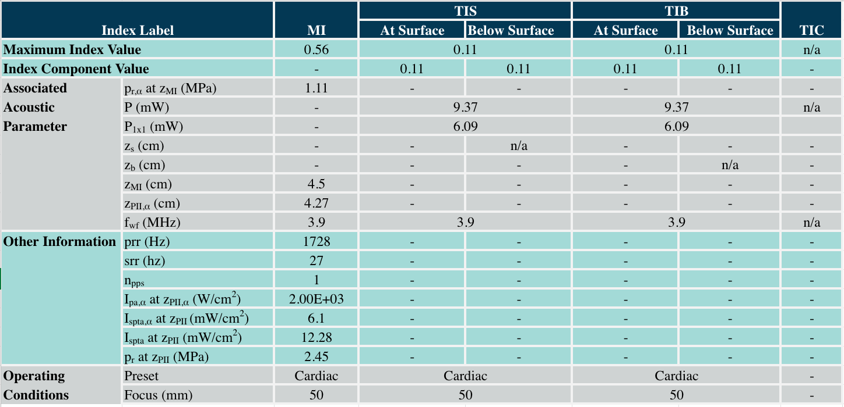

B-Mode Operation – Universal Probe – Vascular Preset
Figure 5.12: B-Mode Vascular Preset Acoustic Output Table Universal Probe
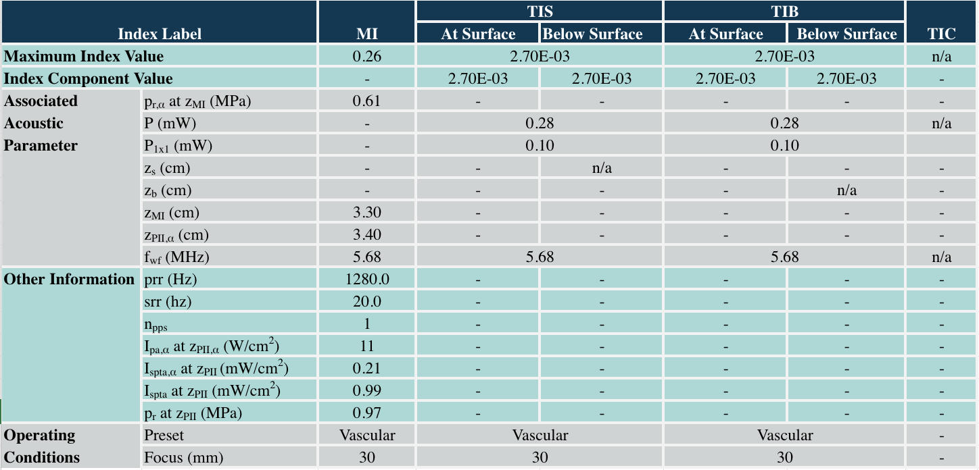

M-Mode Operation – Universal Probe
Figure 5.13: M-Mode Acoustic Output Table Universal Probe
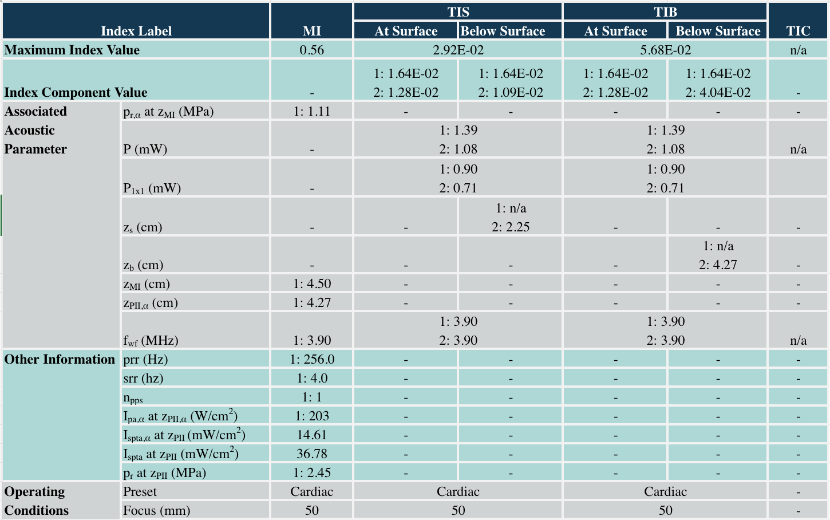

M-Mode Operation – Universal Probe – Vascular Preset
Figure 5.14: M-Mode Vascular Preset Acoustic Output Table Universal Probe
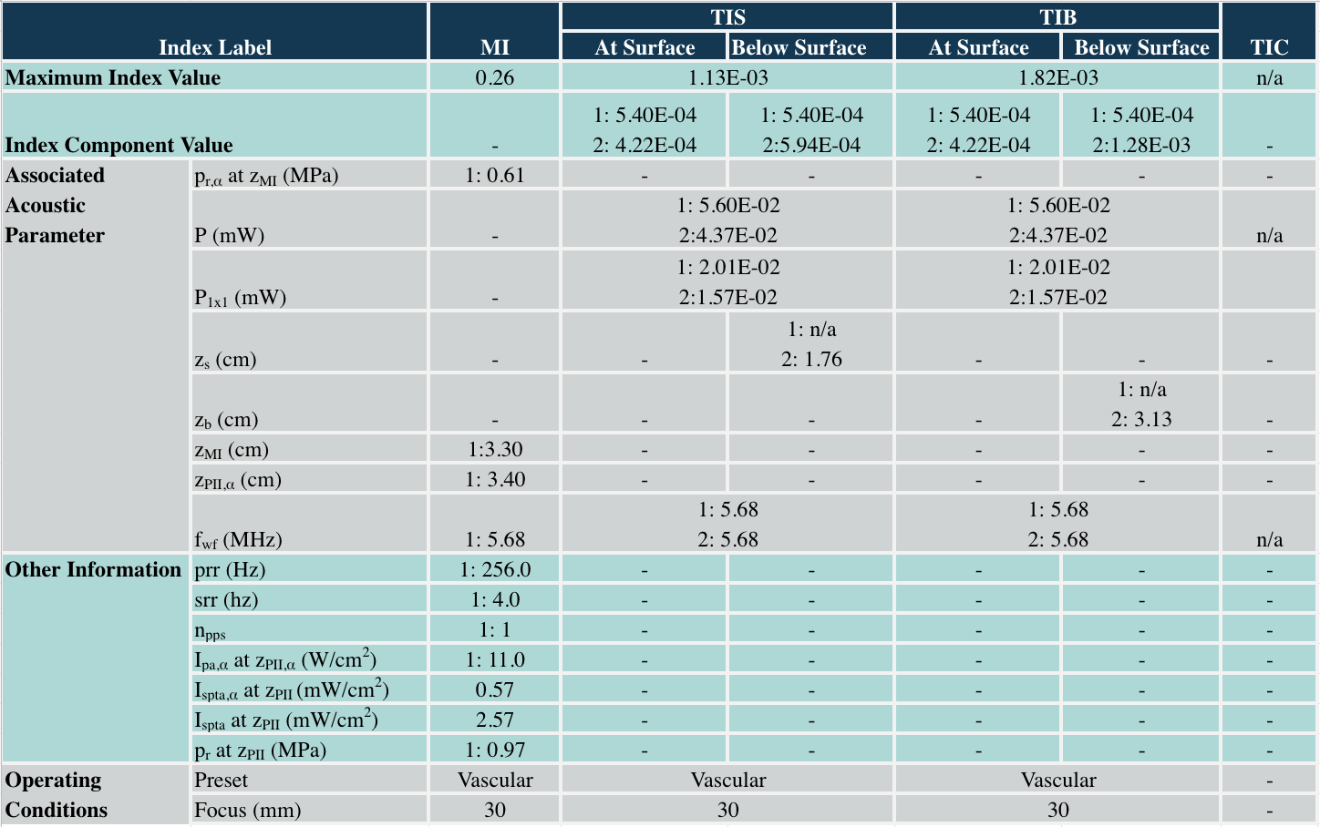

Color Doppler Mode Operation – Universal Probe
Figure 5.15: Color Doppler Mode Acoustic Output Table Universal Probe
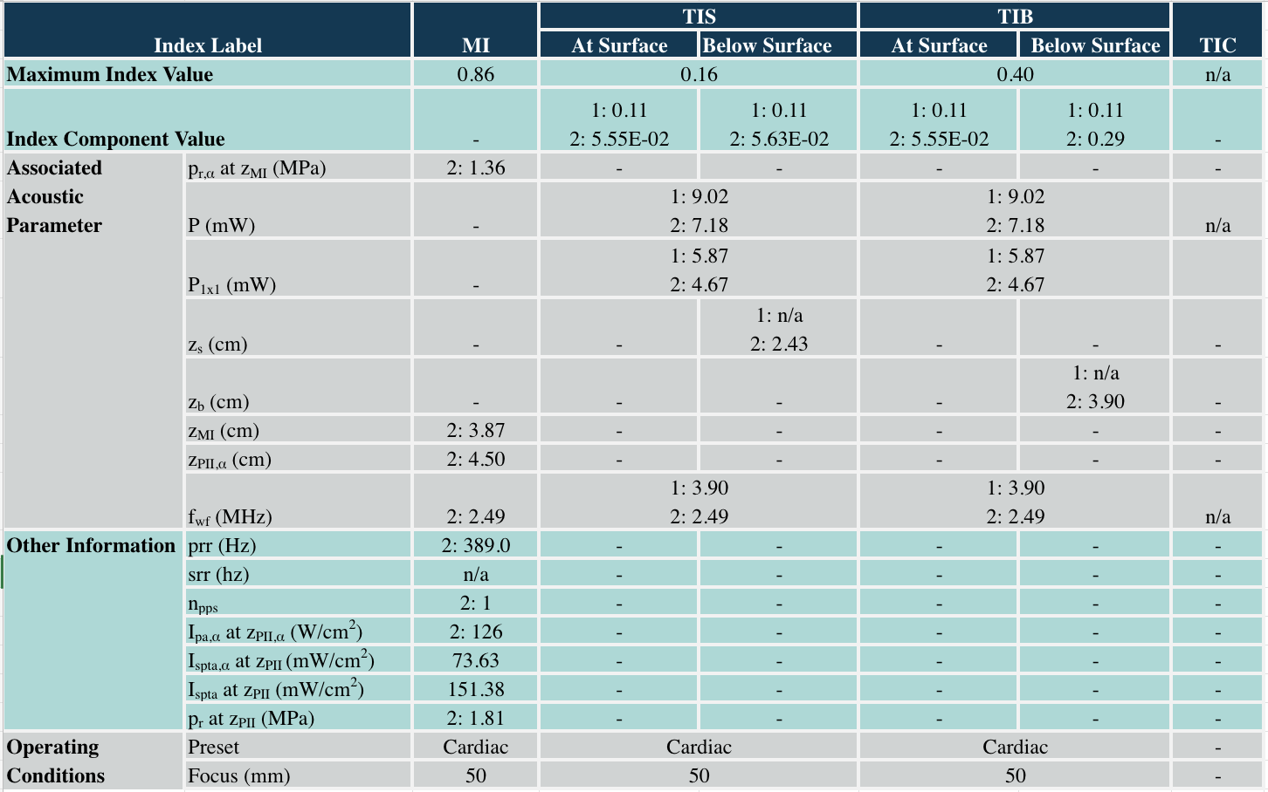

Color Doppler Mode Operation – Universal Probe – Vascular Preset
Figure 5.16: Color Doppler Mode Vascular Preset Acoustic Output Table Universal Probe
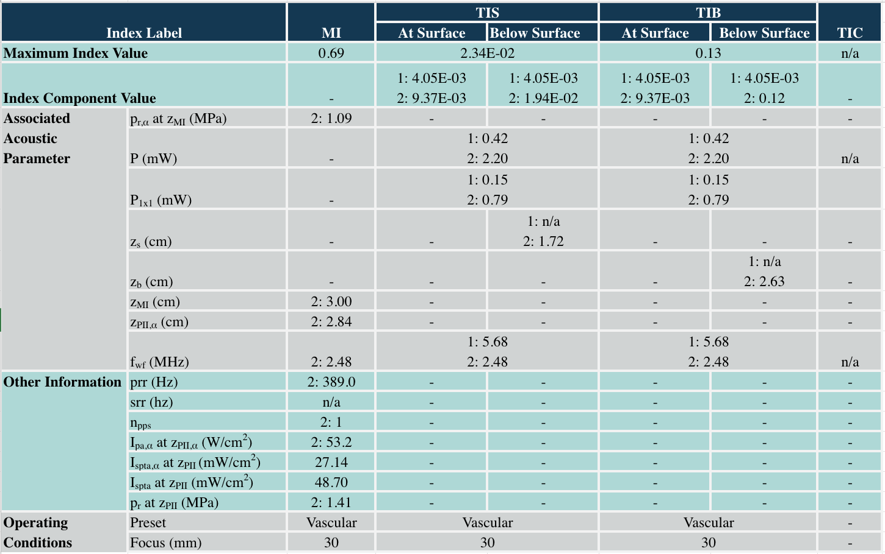

Acoustic Output Table Key
For ultrasound terms not included in this glossary, refer to Recommended Ultrasound Terminology, Third Edition, published by AIUM.
- Aaprt Area of the active aperture measured in cm2.
- deq(z) Equivalent beam diameter as a function of axial distance z, and is equal to [(4/π)(Wo/ITA(z))]0.5, where ITA(z) is the temporal-average intensity as a function of z in centimeters.
- deq@PIImax Equivalent beam diameter at the point where the free-field, spatial-peak pulse intensity integral is
a maximum in centimeters.
- depth Refers to the depth of the display. A constant speed of sound of 1538.5meters/second is assumed in the calculation of echo position in the image.
- Dim. of Aaprt Active aperture dimensions for the azimuthal (x) and elevational (y) planes in centimeters.
- fc The center frequency (MHz). For MI, fc is the center frequency associated with the transmit pattern giving rise to the global maximum reported value of MI. For TI, when using combined modes involving transmit patterns of unequal center frequency, fc is defined as the overall range of center frequencies of the respective transmit patterns.
- in situ In the natural or original position.
- FL Focal length, or azimuthal (x) and elevational (y) lengths if different, measured in centimeters.
- Ipa.3@MImax Derated pulse average intensity at the maximum MI in units of W/cm2.
- ISPTA.3 Derated spatial peak, temporal average intensity in units of milliwatts/cm2.
- ISPTA.3z1 Derated spatial-peak temporal-average intensity at axial distance z1 in units of milliwatts/cm2.
- ITA.3(z1) The derated spatial-peak temporal-average intensity at axial distance in units of milliwatts/cm2.
- MI (mechanical index) An indication of the likelihood of mechanical bioeffects occurring. The higher the MI, the greater the likelihood of mechanical bioeffects.
- PD Pulse duration in microseconds associated with the transmit pattern giving rise to the reported value of MI.
- Pr.3 Derated peak rarefactional pressure associated with the transmit pattern giving rise to the value reported under MI in units of megapascals.
- pr@PIImax Peak rarefactional pressure at the point where the free-field, spatial-peak pulse intensity integral is
a maximum in units of megapascals.
- PRF Pulse repetition frequency associated with the transmit pattern giving rise to the reported value of MI in Hertz.
- TI (thermal index) The ratio of total acoustic power to the acoustic power required to raise tissue temperature by 1°C (1.8°F) under defined assumptions.
- TI type Applicable thermal index for the scanner, imaging mode, and exam type.
- TI value Thermal index value for the scanner, imaging mode, and exam type.
- TIB (bone thermal index) A thermal index for applications in which the ultrasound beam passes through soft tissue and a focal region is in the immediate vicinity of bone.
- TIBnon-scan The bone thermal index in the non-autoscanning mode.
- TIC (cranial bone thermal index) A thermal index for applications in which the ultrasound beam passes through bone near the beam entrance into the body.
- TIS (soft tissue thermal index) A thermal index related to soft tissues.
- TISscan The soft tissue thermal index in an auto-scanning mode.
- TISnon-scan The soft tissue thermal index in the non-autoscanning mode.
- W3(z1) Derated ultrasonic power at axial distance z1 in units of milliwatts.
- Wo Ultrasonic power, except for TISscan, in which case it is the ultrasonic power passing through a one-centimeter window in units of milliwatts.
- z1 Axial distance corresponding to the location of maximum [min(W3(z), ITA.3(z) x 1 cm2)], where z ≥ _zbp in centimeters.
- Zbp 1.69 (Aaprt) in centimeters.
- Zsp For MI, the axial distance at which pr.3 is measured. For TIB, the axial distance at which TIB is a global maximum (for example, zsp = zb.3) in centimeters.
- z@PII.3max The axial distance corresponding to the maximum of the derated spatial-peak pulse intensity integral (megapascals).

Control Effects Guidance Documents
For more information about ultrasonic bioeffects and related topics, see the following:
- “Bioeffects and Safety of Diagnostic Ultrasound.” AIUM Report, January 28, 1993.
- “American Institute of Ultrasound in Medicine Bioeffects Consensus Report.” Journal of Ultrasound in Medicine, Volume 27, Issue 4, April 2008.
- Third Edition of the AIUM Medical Ultrasound Safety brochure, 2014.
- Information for Manufacturers Seeking Marketing Clearance of Diagnostic Ultrasound Systems and Scanners. FDA, September 2008.
- WFUMB. “Symposium on Safety of Ultrasound in Medicine: Conclusions and Recommendations on Thermal and Non-Thermal Mechanisms for Biological Effects of Ultrasound.” Ultrasound in Medicine and Biology, 1998: Volume 24, Supplement 1.
- Information for Manufacturers Seeking Marketing Clearance of Diagnostic Ultrasound Systems and Scanners, FDA, 2008.
- Medical Ultrasound Safety, American Institute of Ultrasound in Medicine (AIUM), 2014.
- Acoustic Output Measurement and Labeling Standard for Diagnostic Ultrasound Equipment, American Institute of Ultrasound in Medicine, 1993.

